**The Guardian Controls Door Sentry will install good cold room door policy, save energy, reduce maintenance, protect food quality and keep operatives safe.**

**Cold and freezer room doors remaining open for longer than necessary are a continual source of wasted energy. Door openings allow warm moist air to enter the temperature and humidity controlled room, which requires additional cooling.**

The higher the outside ambient temperature and humidity the greater the impact on the room. Excessive door opening can lead to ice build up in the room and put stored produce at risk.

# Features

**Wall and panel mount**

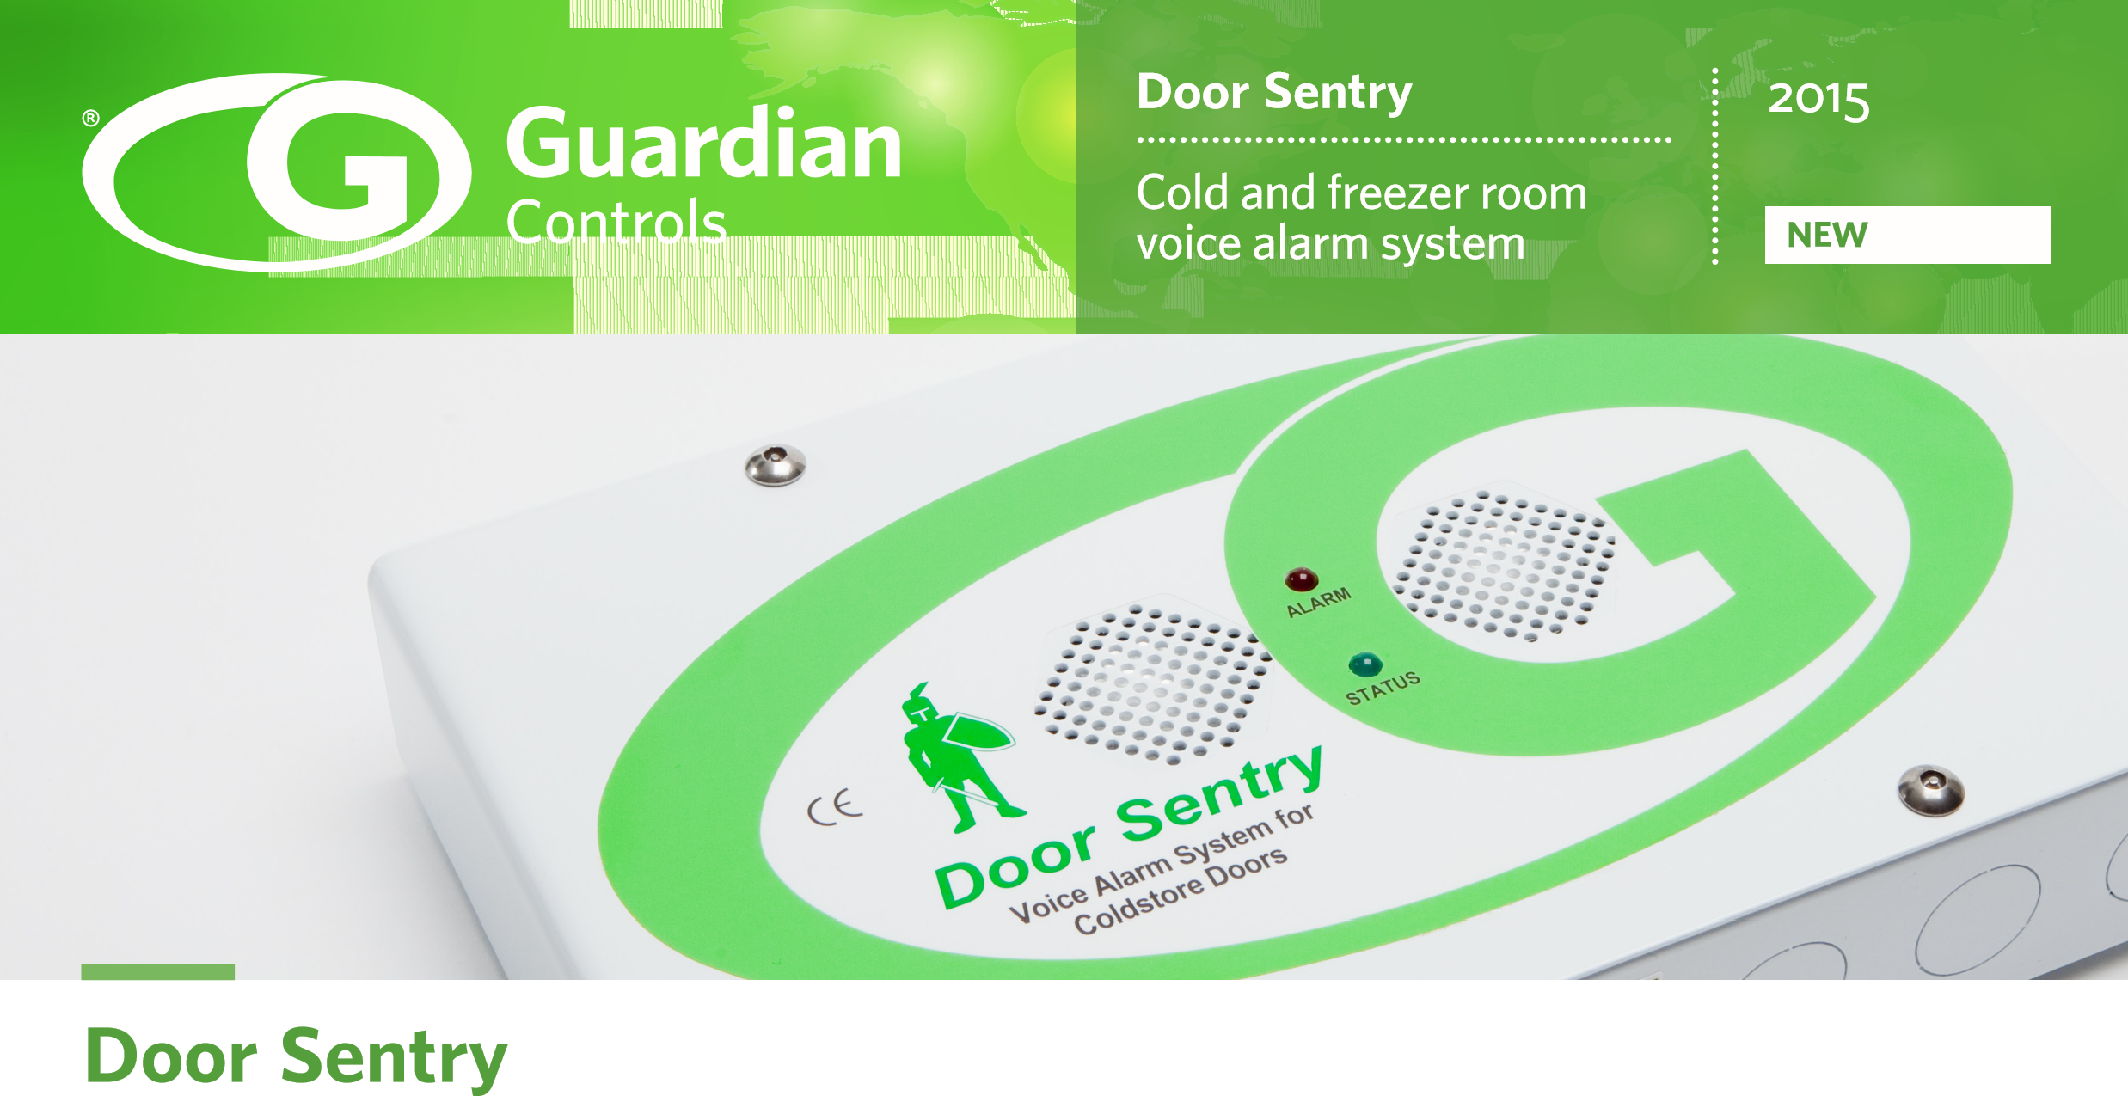**230v and 24v**

# Key Benefits

**Successfully launched in 230v wall mount form during 2014, over 2000 units have been retrofitted with two of the UKs leading supermarket groups, as part of energy saving initiatives.**

On the back of this success panel mount and 24v options are now available for new stores and refits.

* **Saves up to 17% of room energy costs**
* **Installs good operator door policy**
* **Loud audio messages**
* **Robust door sensors resistant to abuse**
* **Protects food quality and operator safety**
* **Door open data via RS485 or Ethernet**
* **Quick and easy installation**
* **Non-intrusive, no cold room access required**

|  |
| --- |
| **Tamperproof case & sensors**  **Range of audio messages**  **Engineer volume/time adjustment**  **2**  **additional inputs & outputs**  **Default; Man Trapped and Gas Sensor**  **Additional input for phase**  **fail on 24v**  **Status LEDs**  **Optional RS485 or Ethernet**  56  **www.uardian-controls.com**  +44 (0)1270 760 599  **sales@guardian-controls.com**  **17**  **%**  **energy**  **saved** |

* **Compatible with existing control/monitoring**

# Use in conjunction with

**The Door Sentry works well in conjunction with the Guardian Controls Fan Speed Optimiser (FSO), which has been specifically developed to reduce the direct and indirect energy used by single phase evaporator fan motors in cold and freezer rooms.**

## The FSO delivers verified average savings of 36%

The Door Sentry’s sensors generate a door open/close signal. The FSO can use this signal to reduce the fan speed for a pre-determined time to make it more comfortable for staff entering the room, reduce the volume of warm moist air entering the room and save more energy.

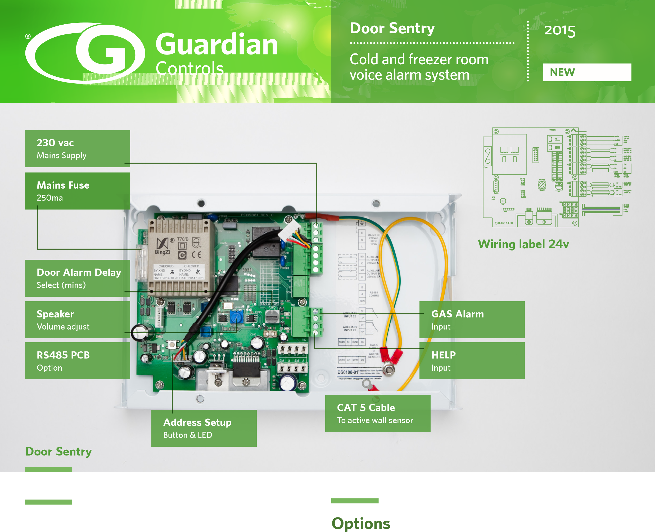When the door is closed or if the thermostat calls for it at any point during optimisation, the FSO returns the fans to full normal operation.

**CDA-01**

Wall Mount 230vac mains input

**CDA-02**

Wall Mount 230vac mains input with RS485

**CDA-03**

Wall Mount 230vac mains input with IPM-04

**CDA-04**

Panel Mount 24vdc input & Phase Fail I/O

**CDA-05**

Wall Mount 24vdc input & Phase Fail I/O

**CDA-06**

Panel Mount 24vdc input, Phase Fail I/O & IPM-04

## IPM-04

Optional Ethernet Communications