**TABLE OF CONTENTS**

1. GENERAL INFORMATIONS 39

2. WARRANTY 40

3. DESCRIPTION OF THE MONOBLOCK 41

4. IDENTIFICATION PLATE 48

5. PRECAUTIONS FOR USE AND MAINTENANCE 49

6. SAFETY PRINCIPLES 50

7. PROPER AND IMPROPER USE OF THE MACHINE 51

8. TRANSPORT AND HANDLING 51

9. STORAGE 51

10. PREPARATION FOR INSTALLATION 52

11. INSTALLATION 53

12. ELECTRICAL CONNECTION 57

13. STARTUP OF THE MONOBLOCK 57

14. OPERATION OF THE MACHINE 58

15. USER INTERFACE AND CONTROL LOGIC 59

16 FOOD STORAGE 65

17. FOOD PRESERVATION 65

18. ORDINARY MAINTENANCE 66

19. EXTRAORDINARY MAINTENANCE AND REPAIRS 67

20 RECYCLING AND DISPOSAL 68

21. WARRANTY TERMS 69

22. ANNEXES 71

# 1. GENERAL INFORMATIONS

**General informations:**

This use and maintenance handbook is an integral part of the UMZ monoblock, (identified as “MACHINE” in the following pages, manufactured by MTH. For this purpose it should follow the machine if transferred to a new user or owner.

This manual has the function of providing operators and maintenance technicians the essential instructions to operate correctly and safely; for this reason it must be carefully stored throughout the life cycle of the machine.

This handbook assumes that in the environments in which the machine is installed, the regulations in force regarding occupational safety and hygiene are observed, and that the personnel in charge of operation and maintenance are trained to be able to correctly comprehend the information provided.

The configuration of some parts or devices described or depicted in this manual may differ from that with which the machine is equipped in the specific set-up. The dimensioned drawings and photographs in this text are provided as an example as a reference for easier understanding of the text.

In the manual there are images that depict the machine open or without guards, these are shown for illustrative purposes only, it is strictly forbidden to use the machine in these conditions.

MTH S.r.l. reserves the right to update part or all of the contents of this manual without notifying the customer of any changes.

**Property of information:**

This handbook contains confidential informations. All rights reserved.

The use of his handbook is only allowed by the client who received it with the MACHINE and only for the purpose of installation, use and maintenance of the unit to which the manual refers.

MTH S.r.l. does not assume any responsibility for direct or indirect damage to persons, property or domestic animals as a result of use of the machine in conditions different from those planned. **Contents of the Use and maintenance handbook:**

This manual is intended for operators and technicians so that they can know and use the machine properly. In fact, the manual contains a functional description of the machine and its main components.

In addition, the main directions for transport and installation, proper use and adjustment, cleaning and maintenance of the machine are provided.

Finally, inside the manual are the main instructions for meeting the most basic safety and accident prevention rules.

# 2. WARRANTY

All equipment and refrigeration units are covered by **WARRANTY**.

The **WARRANTY CERTIFICATE** is attached with this booklet for each product supplied. For the guarantee to be effective, it is necessary to keep the documentation relating to the purchase together with the receipt to be shown, if necessary, to the staff of the guarantee service.

Refer to the "Warranty Conditions" section of this manual for warranty conditions.

## WARRANTY LAPSE

As stated in Section 5 of the "Warranty Conditions" chapter, the warranty claim expires, and therefore any interventions by MTH technicians or those commissioned by it will be charged if even one of the following circumstances occurs:

1. breaking of tamper-resistant seals placed by MTH S.r.l.;
2. damage resulting from force majeure in general or occurring during transport: delivery is made EXW (Incoterms of the ICC); responsibility for these damages is of the carrier, and therefore to the same must be contested upon receipt. Likewise, any damage resulting from improper installation or maintenance of the equipment will not be accepted as a valid issue of contestation for warranty purposes;
3. installation of the machine in different conditions from those specified in this manual;
4. connection to the electrical and/or plumbing network through a system of insufficient capacity or that does not comply with current regulations. In particular, reference is made to the technical regulations and good engineering practices relating to the ground connection of equipment;
5. lack of operation due to power failure, grid voltage variations, or similar accidents and resulting failures;
6. failures due to accidental breakage (by way of example but not limited to: disconnected plugs, blown fuses), and other inconveniences resulting in any case from external factors and from the Buyer's negligence;
7. any disassembly, modification or tampering of the machine or its components performed by the user or unauthorized personnel;
8. use of spare parts that are not original or not specified by MTH S.r.l;
9. use in violation of what is specified by the regulations in force in the country of use;
10. destination of the equipment for uses other than those for which it was prepared;
11. use of the appliance in a manner not in accordance with the contents of this Operation and Maintenance Manual;
12. total or partial non-observance of the instructions in this Manual;
13. missing or incorrect maintenance;
14. changing the setting parameters of the supplied controller; the Buyer or user may only change the temperature set point and defrost interval (IdF).

To exercise the warranty right, the Buyer must submit to the Seller:

1. WARRANTY CERTIFICATE;
2. one of the following documents evidencing the date of delivery: INVOICE, TRANSPORT DOCUMENT. The absence of one of the documents does not allow to assess the validity of the warranty and therefore the intervention will be considered at the expense of the Buyer and charged to the same;
3. the Buyer must provide the unit and all electrical cables and accessories supplied with the machine.

These accessories must be in integral condition or the warranty will be invalidated;

1. the customer must provide the unit with the seals placed by MTH S.r.l. undamaged.

**Service Centers**

(Sales, Support, Parts and Sales Representation)

SERVICE CENTER STAMP

For any need concerning the use, maintenance or request for spare parts, the Customer is encouraged to contact the authorized service centers, specifying the equipment details shown on the license plates.

# 3. DESCRIPTION OF THE MONOBLOCK

The machine discussed in this document is a monoblock refrigeration system called UMZ, designed to be installed on the wall of refrigerated cells. The monoblock consists of a condensing unit and an evaporator connected by suitable self-supporting brackets to permit installation on the cell wall. Refrigeration is accomplished by exploiting the physical characteristics of the refrigerant which flows in a sealed circuit in the machine, by means of a compression refrigeration cycle.

The monoblock is equipped with a logic control unit that can be programmed via the electronic controller screen.

This makes the UMZ monoblock a machine, in accordance with the Machinery Directive 2006/42/CE. The machine is produced in two versions:

* MBP models for positive temperature, with operating temperature between +5°C and -5°C, under ambient temperature conditions between +15°C and +43°C;
* LBP models for low temperature, with operating temperature range from -15°C to -25°C, under ambient temperature conditions between +15°C and +43°C. LBP models are equipped with an automatic defrosting system that is programmable in frequency and duration.

Machines pressurized with propane (R290, with GWP=3) are equipped with hot gas defrost.

The machines are manufactured with single refrigerant circuit or dual circuit depending on the cooling capacity delivered and the permitted charge limitations (a maximum of 150g per single refrigerant circuit is provided for flammable gases). Differences in structure between the two models are highlighted on page 44-47.

The main characteristics of the machine can be determined by correctly reading the code on the identification plate.

Three phase voltage = T

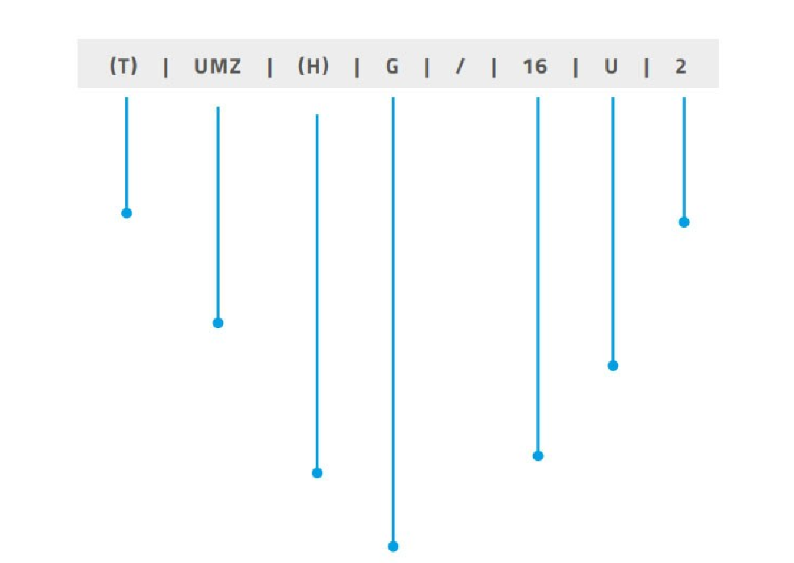

Saddle monoblock = UMZ

Medium temperature = H

Low temperature = void

R290 = U

Approximate volume of a typical cell [mc]

Compressor

A = Embraco

S = Secop

Size

1

2

3

Single phase voltage = void

Fig. 1 Example of machine identification code

In Tab.1 and Tab.2 are displayed correspondences between part number, UMZ monoblock model, frame version, size, refrigerant gas type, and number of circuits by which the machine is characterized.

|  |  |  |  |  |  |
| --- | --- | --- | --- | --- | --- |
| **UMZ LBP** | | | |  |  |
| **MTH code** | **Model** | **Gas type** | **Size** | **Frame version** | **N° circuits** |
| **19135030** | **UMZU/03S1** | **R290** | **1** | **\*V2** | **1** |
| **19135031** | **UMZU/03S1** | **R290** | **1** | **\*\*V2 - T150** | **1** |
| **19135040** | **UMZU/04A1** | **R290** | **1** | **\*V2** | **1** |
| **19135041** | **UMZU/04A1** | **R290** | **1** | **\*\*V2 - T150** | **1** |
| **19135080** | **UMZU/08S2** | **R290** | **2** | **\*V2** | **2** |
| **19135081** | **UMZU/08S2** | **R290** | **2** | **\*\*V2 - T150** | **2** |
| **19135130** | **UMZU/13A3** | **R290** | **3** | **\*V2** | **2** |
| **19135131** | **UMZU/13A3** | **R290** | **3** | **\*\*V2 - T150** | **2** |

*V2 frame version suitable for cell thicknesses up to 100mm

**V2-T150 frame version suitable for cells up to 150mm thick

Tab.1 UMZ LBP Models

|  |  |  |  |  |  |
| --- | --- | --- | --- | --- | --- |
| **UMZ MBP** | | | |  |  |
| **MTH code** | **Model** | **Gas type** | **Size** | **Frame version** | **N° circuits** |
| **19131040** | **UMZHU/04S1** | **R290** | **1** | **\*V2** | **1** |
| **19131041** | **UMZHU/04S1** | **R290** | **1** | **\*\*V2 - T150** | **1** |
| **19131050** | **UMZHU/05S1** | **R290** | **1** | **\*V2** | **1** |
| **19131051** | **UMZHU/05S1** | **R290** | **1** | **\*\*V2 - T150** | **1** |
| **19131090** | **UMZHU/09S2** | **R290** | **2** | **\*V2** | **2** |
| **19131091** | **UMZHU/09S2** | **R290** | **2** | **\*\*V2 - T150** | **2** |
| **19131120** | **UMZHU/12S2** | **R290** | **2** | **\*V2** | **2** |
| **19131121** | **UMZHU/12S2** | **R290** | **2** | **\*\*V2 - T150** | **2** |
| **19131180** | **UMZHU/18A3** | **R290** | **3** | **\*V2** | **2** |
| **19131181** | **UMZHU/18A3** | **R290** | **3** | **\*\*V2 - T150** | **2** |

*V2 frame version suitable for cell thicknesses up to 100mm

**V2-T150 frame version suitable for cells up to 150mm thick

Tab.2 UMZ MBP models

**MAIN COMPONENTS UMZ SINGLE REFRIGERATION CIRCUIT FRAME V2**

**Components on board:**

1. Condenser
2. Compressor
3. Compressor box
4. Thermostat – Control interface
5. Electrical box
6. Condenser fan
7. Mounting bracket
8. Evaporator
9. Evaporator fan
10. Condensate collection tray
11. Cell temperature sensor
12. Evaporator condensate collection tray
13. Drier filter
14. Insulated suction tube
15. Hot cable for condensate discharge
16. Condensate discharge fitting

**WARNING: The pictures show the machine without the outer frame and side guards, these are for illustrative purposes only. It is strictly forbidden to use the machine open or without guards.**

8

12

1

7

5

4

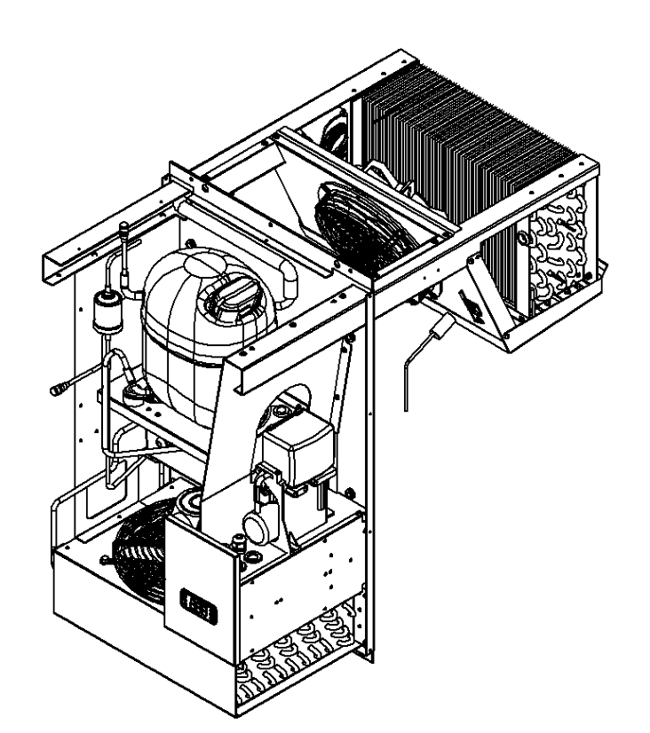

14

11

10

13

6

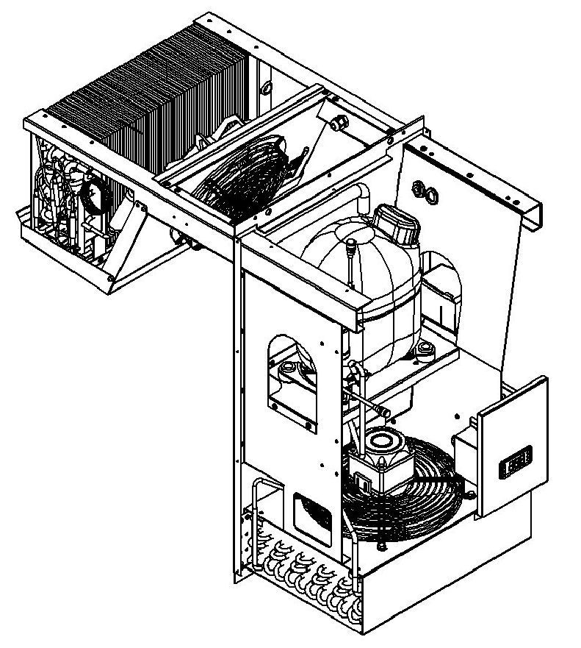

16

15

9

3

2

Fig.2 Representation of UMZ single refrigeration circuit V2with electrical resistance defrost

**MAIN COMPONENTS UMZ DOUBLE REFRIGERATION CIRCUIT FRAME V2**

**Components on board:**

1. Condenser
2. Compressor
3. Compressor box
4. Thermostat – Control interface
5. Electrical box
6. Condenser fan
7. Mounting bracket
8. Evaporator
9. Evaporator fan
10. Condensate collection tray
11. Cell temperature sensor
12. Evaporator condensate collection tray
13. Drier filter
14. Insulated suction tube
15. Hot cable for condensate discharge
16. Condensate discharge fitting
17. Hot gas solenoid valve

**WARNING: The pictures show the machine without the outer frame and side guards, these are for illustrative purposes only. It is strictly forbidden to use the machine open or without guards.**

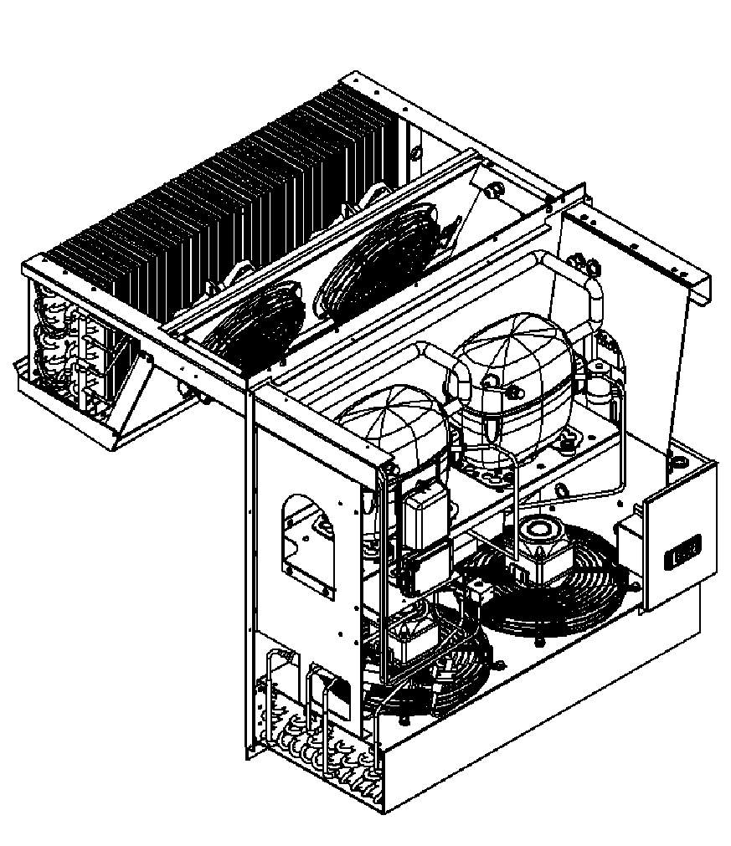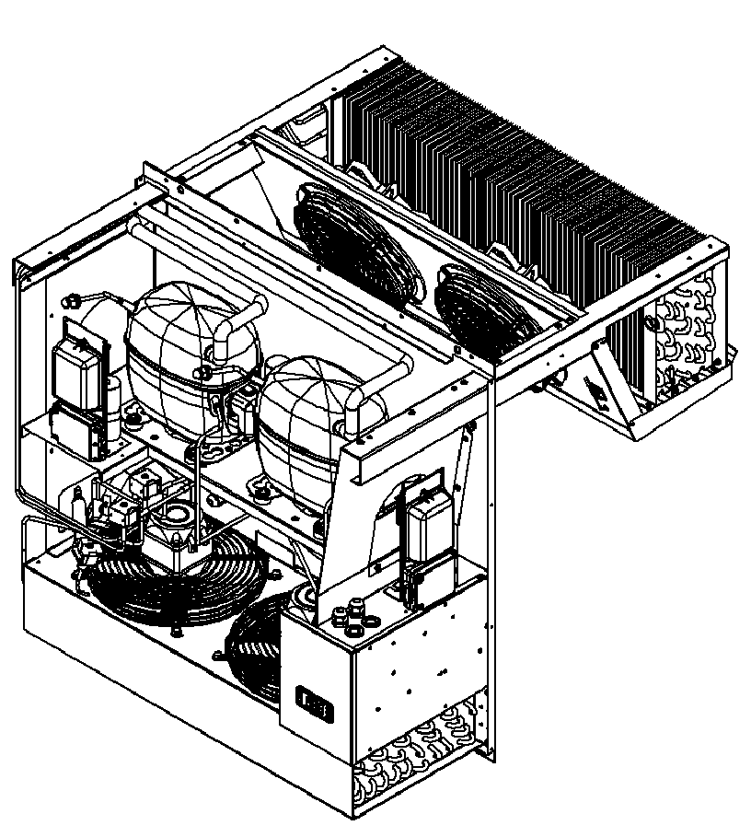

6

14

13

9

1

8

5

4

17

3

11

2

7

12

10

16

15

Fig.3 Representation of UMZ double refrigeration circuit V2 with hot gas defrost

# 4. IDENTIFICATION PLATE

For a correct and quick identification of the product, several plates containing the characteristics of the machine are placed on the monoblock. The first plate is located on the outside of the machine on the bottom right side (1), the second one is located on the compressor (2).

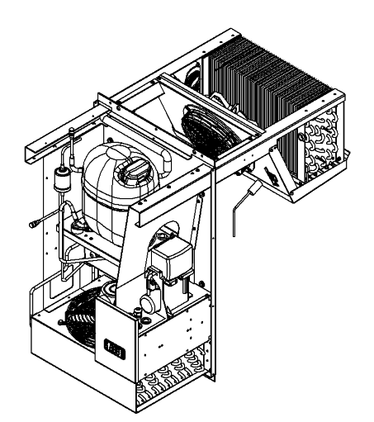

2

Fig.5 Internal plate position

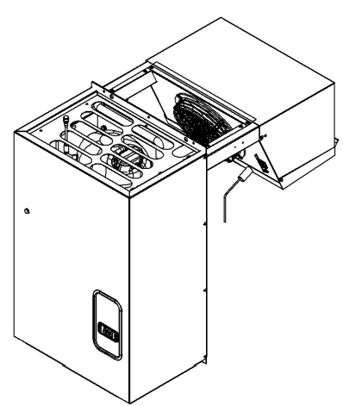

1

Fig.4 External plate position

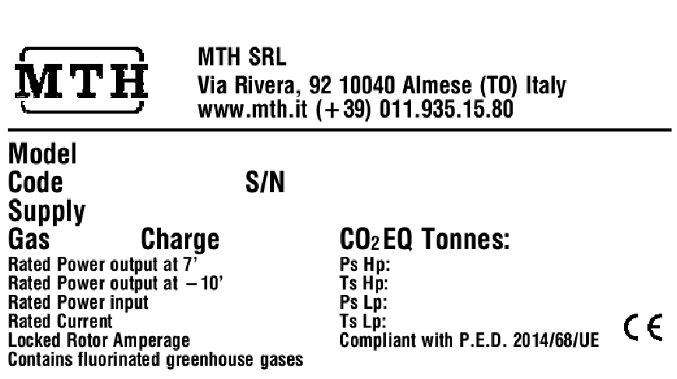

[

A

]

[

B

]

[

D

]

[

F

]

[

N

]

]

[

H

[

]

I

]

J

[

K

[

]

]

M

[

[

O

]

P

]

[

[

]

C

]

E

[

]

G

[

[

L

]

Fig.6 Identification plate of the UMZ monoblock The data on the identification plates are listed in the following legend:

1. UMZ model I. Output power at –10°C (MBP) or at -30°C (LBP)

[W]

1. MTH code of the machine
   1. Rated input power [W]
2. Serial number
   1. Rated current absorption [A]
3. Supply voltage and frequency
   1. Locked rotor current [A]
4. Refrigerant gas type
   1. Max operating pressure (high pressure) [bar]
5. Gas charge [kg]
   1. Max operating temperature (high pressure) [°C]
6. CO2 equivalent Tonnes
   1. Max operating pressure (low pressure) [bar]
7. Output power at 7°C (MBP) or at -23°C (LBP) [W]
   1. Max operating temperature (low pressure) [°C]

# 5. PRECAUTIONS FOR USE AND MAINTENANCE

Before installation, commissioning and maintenance operations, read this manual carefully.

Always ensure that the operator or maintainer has correctly understood both the contents of the manual and

the symbology of the plates or labels placed on the machine. Keep the labels or markings placed on the machines clean and clearly legible, and do not remove them.

The purpose of this manual is to provide the customer all the necessary information so that, in addition to pro- per use of the equipment, he is able to operate it as independently and safely as possible. It includes information concerning the technical aspect, operation, machine shutdown, maintenance, spare parts and safety.

Before the start-up of the machine, it is necessary to:

* always make sure that no unauthorized personnel are present and that all guards, covers and any other protective devices are mounted, secured and properly positioned. Protective guards should in any case never be removed by production operators, but in case of need (maintenance, replacement of parts, repairs, lubrication, etc.) they should only be removed by maintenance personnel who are specialized and authorized;
* verify that there has been no damage during the assembly phase;
* check with particular care the integrity of the control panel, electrical cables and piping;
* check the exact connection of all external power sources;
* check the free movement and possible free rotation of all moving parts (fans, etc.);
* check that the cold room is empty or in any case free of whatever goods or frozen products;

**WARNING: Before carrying out any kind of work on the machine, it is necessary to switch it off, disconnect it from the power supply by acting on the circuit breaker and wait until there are no moving parts and hot surfaces have cooled down. It is absolutely forbidden to remove the safety guards to carry out routine maintenance operations without first disconnecting the machine from the power supply. The manufacturer disclaims any liability for accidents resulting from failure in this respect.**

**WARNING: All operations to be performed on the machine must always be carried out by qualified technicians, wearing all necessary personal protective equipment, using standard working tools and complying with all applicable safety regulations.**

To ensure the full efficiency and safety of the machine, periodic maintenance actions must be carried out.

In case of failure or malfunction of the machine, refer only to qualified technical personnel or directly to the manufacturer company, reporting the identification data of the machine. Users must not perform operations restricted to maintenance personnel or qualified technicians.

This manual must be carefully stored and placed in a place easily accessible to the operator or maintainer. MTH S.r.l. accepts no responsibility for any accident or damage to persons or property resulting from failure to observe the safety requirements described in this manual and those in force at national level.

The machine subject of this manual is manufactured exclusively for cold room refrigeration and is designed to use only one refrigerant gas; it is therefore essential to use the machine in accordance with the refrigerant for which it was built and supplied by the manufacturer. The machine was designed and constructed to operate in environments where a potentially explosive atmosphere is not present. Any use of the machine differing from that described will be considered improper use and therefore, as well as any reasonably predictable misuse, will not involve the responsibility of MTH S.r.l. For further information, please contact MTH S.r.l.

# 6. SAFETY PRINCIPLES

The air-cooled refrigeration unit is manufactured in accordance with the provisions of EU Directive 2006/42/EC, 97/23/EC, 2006/95/EC and the relevant essential health and safety requirements.

There are no danger zones during use, as the unit is equipped with all necessary safety devices.

The machine has been designed in accordance with the principles contained in the relevant paragraphs of the

standards shown in the following table so as to eliminate or minimize risks during both operation and mainte- nance:

|  |  |
| --- | --- |
| **STANDARD** | **DESCRIPTION** |
| UNI EN ISO 12100:2010 | Safety of machinery - General principles for design - Risk assessment and risk reduction |
| UNI EN ISO 14120:2015 | Safety of machinery - Guards - General requirements for the design and construction of fixed and movable guards |
| UNI EN ISO 13857:2019 | Safety of machinery - Safety distances to prevent hazard zones being reached by upper and lower limbs |
| UNI EN 1127-1:2019 | Explosive atmospheres - Explosion prevention and protection - Part 1: Basic concepts and methodology |
| UNI EN 378-1:2021 | Refrigerating systems and heat pumps - Safety and environmental requirements - Part 1: Basic requirements, definitions, classification and selection criteria |
| UNI EN 378-2:2017 | Refrigerating systems and heat pumps - Safety and environmental requirements -  Part 2: Design, construction, testing, marking and documentation |
| CEI EN 60204-1:2018 | Safety of machinery - Electrical equipment of machines - Part 1: General requirements |
| IEC 60335-1:2020 | Household and similar electrical appliances - Safety - Part 1: General requirements |

Tab.3 Main harmonised standards used in the design of the machine

Parts and components supplied by third parts and installed in the machine are CE-marked (when required), comply with current reference directives, and are free from risks to people's health.

The machine is equipped with safety devices such as fixed guards in order to prevent hazardous conditions for people or damage to the refrigeration system caused by residual risks.

The varnishes used as corrosion protection for the evaporator are not toxic or harmful but compatible for food use.

No materials considered carcinogenic (e.g., asbestos, beryllium, etc.) or radioactive materials have been used. If servicing and/or maintenance has to be carried out by removing guards and safety devices, always make sure that power sources have been turned off first.

For adjustment and maintenance work, SCRUPULOUSLY follow the technical drawings attached to this manual.

For further information or clarification, please contact the service technicians.

The declaration of incorporation will be provided to the manufacturer at the time of purchase.

# 7. PROPER AND IMPROPER USE OF THE MACHINE

The machine is designed to be used exclusively in industrial and commercial refrigeration in stationary location. The UMZ monoblock is designed to be installed exclusively on vertical walls of refrigerated cells.

Each machine can only use the refrigerant gas for which it is designed. The machine is designed and constructed to work in environments where a potentially explosive atmosphere is not present.

The machine must be adequately protected from the atmospheric elements.

As a precautionary measure, it is good practice to keep a dust extinguisher in the proximity of the machine. In addition, to prevent possible fires, it is necessary to keep the monoblock clean of oils, solvents, dusts and other residues.

The use of the machine for operations other than those indicated here might cause damage to persons or to the machine itself and are therefore considered improper uses for which MTH S.r.l. is not responsible.

# 8. TRANSPORT AND HANDLING

Transportation must be carried out by professionally qualified personnel equipped with all necessary personal protective equipment.

Handling has to be performed using a lift truck or trans-pallets equipped with forks or by means of lifting and transporting devices appropriately sized and adequate for the load transported.

Transport and handling of the machine must absolutely be carried out by ensuring that the load is balanced and maintaining the vertical position, respecting any indications placed on the packaging and checking that there are no parts not properly secured or at risk of damage.

Only lay the machine on support planes suitable for supporting its weight.

When transporting and handling, be aware of any possible suspended load.

**WARNING: Damages to the machine caused during transportation and handling are not covered by WARRANTY. Repairs or replacement of damaged parts are the responsibility of the Customer.**

# 9. STORAGE

In case of extended inactivity or in case the machine should be stored for a period of time before installation, the machine has to be stored with precautions concerning the place and time of storage:

* store the unit in an indoor location not accessible to unqualified personnel;
* keep the machine out of the atmospheric agents, in a dry and well-ventilated place;
* secure the machine and its parts from contact with dust, corrosive or flammable substances;
* prevent the machine from being subjected to high temperature fluctuations;
* maintain an ambient temperature between -20°C and +50°C;
* maintain a relative air humidity between 30% and 70%; It is also advisable to store the machine being careful to ensure:
* protection from shock and stress;
* protection from high temperature fluctuations and atmospheric agents;
* that its parts do not get in contact with corrosive or flammable substances;
* if there is packaging for some machine components, do not remove it or take appropriate precautions to protect exposed parts.

# 10. PREPARATION FOR INSTALLATION

Before installing the machine on the refrigerated cell, be sure to properly set up the necessary power supplies for the correct operation of the monoblock.

Install the monoblock in an environment which ensures sufficient air exchange to guarantee adequate cooling of the condenser and compressor unit.

The motor compartment must be free of any obstruction that would preclude or restrict air circulation through  the condenser unit, located in the lower part of the monoblock.

To guarantee proper operation of the unit, the room temperature must be between +15°C and + 43°C.

Non-compliance with these conditions would result in a serious degradation of the machine's performance, premature aging of the compressor, and significantly higher power consumption.

Ensure that the machine is not installed in the proximity of open flames or heat sources such as ovens, radiators, direct sunlight.

Ensure that the machine is not installed near electrical components or highly flammable materials.

Plan to use suitable cable ducts or rigid sleeves to secure piping and cables connecting to power sources. When using monoblock operating with flammable refrigerant (A3, A2, A2L) or equal to R290, it is essential that the installation environment of the machine is well ventilated. Any installation of electrical refrigeration components in the environment remains the responsibility of the end user; the components in question must be suitable with respect to the explosion hazard by assessing a possible leakage of flammable gas (A3, A2, A2L) into the same environment to be refrigerated.

During the installation operations of the monoblock, the operator must wear all necessary personal protective equipment and must carry out the operations using working tools in compliance with standards paying the utmost attention to the surrounding environment and to anything that could cause loss of balance, contusions and cuts.

MTH S.r.l. accepts no responsibility for any damage to property or persons resulting from improper interventions performed by unqualified, untrained or unauthorized personnel. Unless otherwise specified they remain the responsibility of the customer:

* transportation equipment for moving the machine to the installation site;
* tools and instruments required for installation;
* consumables and auxiliary means (e.g. cleaning tools or materials such as non-flammable and noncorrosive detergents);
* utility power supply and power supply for the operation of the machine.

The UMZ monoblock has to be installed in places where good air circulation and ventilation is guaranteed and it must be installed only on a vertical wall. In the case of a different installation it is necessary to contact MTH

S.r.l.

During installation, a suitable free space must be left around the machine to perform maintenance under safe conditions. When positioning the condensing unit and evaporator, respect the minimum measurements shown in Fig.8.

Min. 400 Min. 400

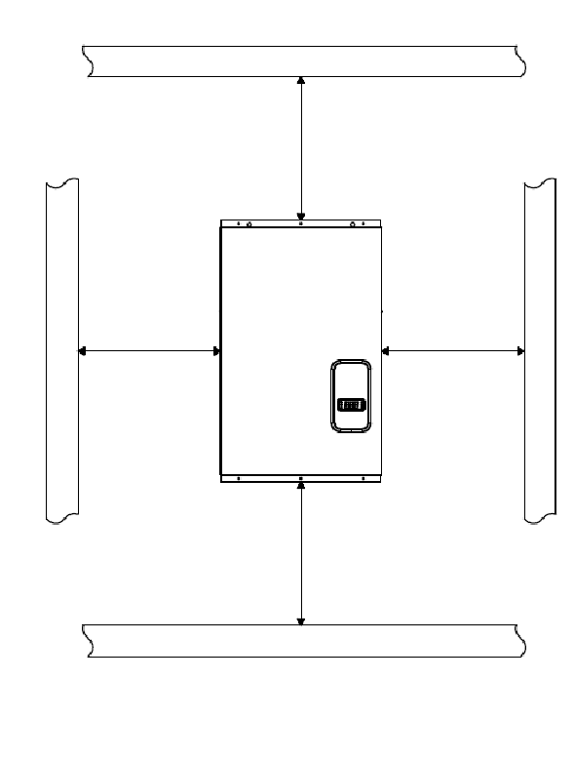

Min. 400

Min. 400

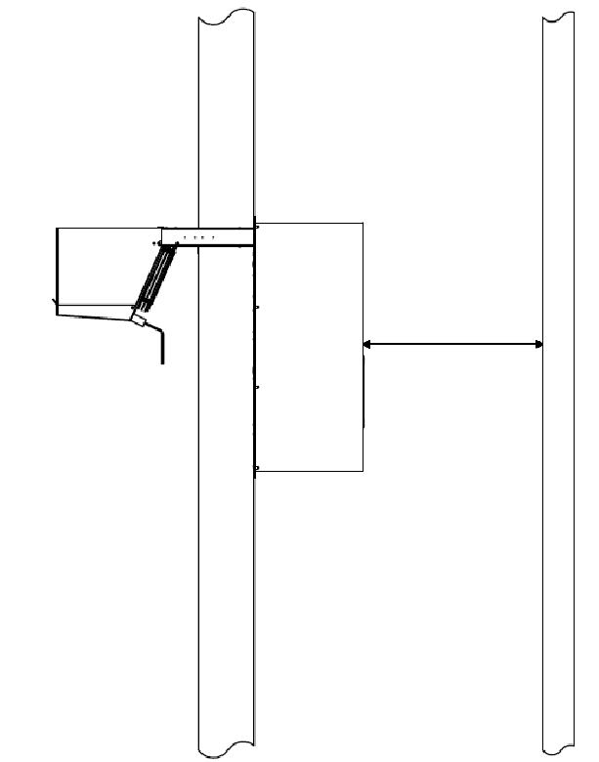

Min. 500

Fig.8 Minimum quota to be respected (mm)

# 11. INSTALLATION

The UMZ monoblock should be installed in places where good air circulation and exchange is guaranteed and should be installed only on a vertical wall. In case of different installation, it is necessary to contact the company MTH S.r.l.

The following cell wall thicknesses (polyurethane insulation) are recommended for proper operation of the machine: cells MBP minimum insulation thickness 60mm, cells LBP minimum insulation thickness 100mm, with insulated floor.

The UMZ monoblock can be installed on the cell wall in saddle mode or by using the panel plug in kit.

**CAUTION: The panel kit is not included with the machine and must be purchased separately. Installation of the panel kit is at the customer's responsibility.**

**Mounting in saddle mode:**

1. Before mounting the cell ceiling, cut the slots provided on the top end and the condensate drain hole according to the diagram in the figure, respecting the specific dimensions related to the size and version of machine purchased (see Tab. 4-5).
2. Lift the monoblock with a forklift or other suitable lifting equipment and position the unit so that the supports correspond with the slots created in the cell wall and attach the monoblock structure to the wall by adjusting the mounting bracket as shown in Fig.11.
3. Connect the evaporator condensate drain tray with the condensate evaporator basin using the provided pipe.
4. Seal the gaps in the grooves with silicone or a suitable sealant (with properties compatible with the use of the cell) to prevent any infiltration of hot air into the cell.

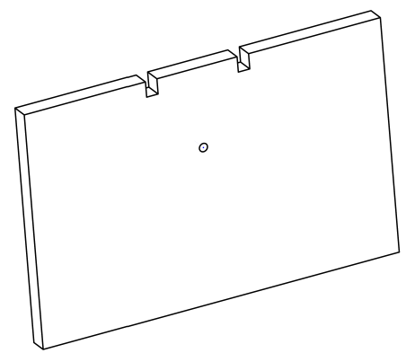

1

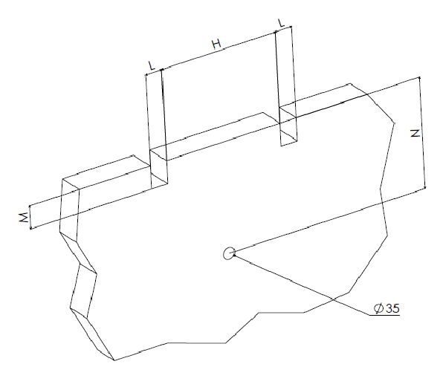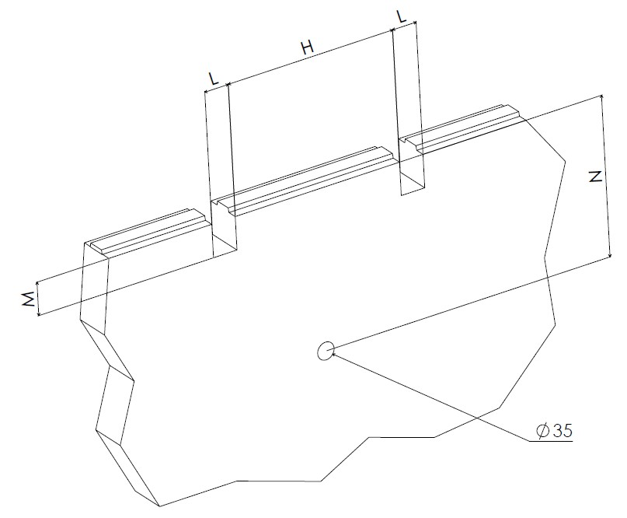

Fig.9 Preparation of panels for assembly

|  |  |  |  |  |  |  |  |  |  |  |  |  |  |  |  |  |  |  |  |  |  |  |  |  |  |  |  |  |  |  |  |  |  |  |  |  |  |  |  |  |  |
| --- | --- | --- | --- | --- | --- | --- | --- | --- | --- | --- | --- | --- | --- | --- | --- | --- | --- | --- | --- | --- | --- | --- | --- | --- | --- | --- | --- | --- | --- | --- | --- | --- | --- | --- | --- | --- | --- | --- | --- | --- | --- |
| |  |  |  |  |  | | --- | --- | --- | --- | --- | | **DIMENSIONS** | **H** | **L** | **M** | **N** | | **SIZE 1** | 350 | 50 | 65 | 340 | | **SIZE 2** | 650 | 50 | 65 | 340 | | **SIZE 3** | 520 | 60 | 75 | 490 | | |  |  |  |  |  | | --- | --- | --- | --- | --- | | **DIMENSIONS** | **H** | **L** | **M** | **N** | | **SIZE 1** | 350 | 50 | 55 | 330 | | **SIZE 2** | 650 | 50 | 55 | 330 | | **SIZE 3** | 520 | 60 | 65 | 480 | |

Tab.4 Slots and hole dimensions for mounting Tab.5 Slots and hole dimensions for mounting

with Algor cells with traditional cells

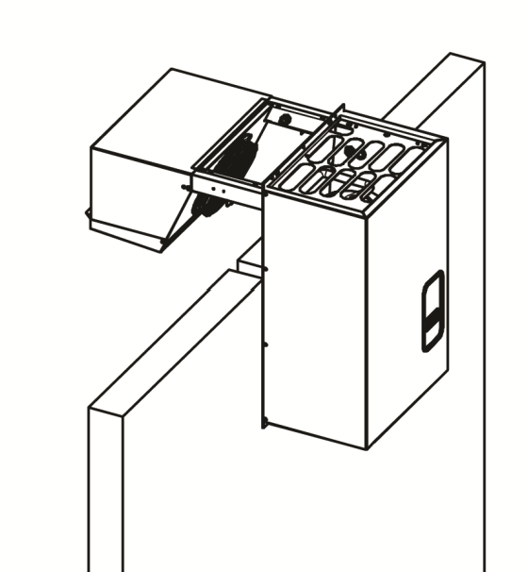

2

Fig.10 Monoblock mounting in saddle mode

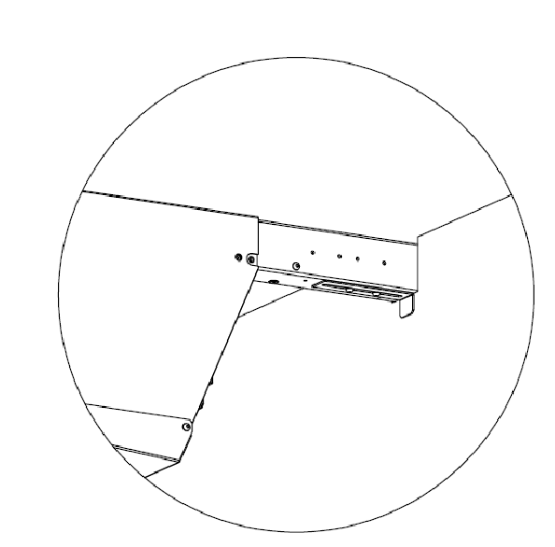

MOUNTING BRACKET

For cells up to 100 mm thick, fix the

bracket in position A

For cells 120 to 150 mm thick fix the

bracket in position B

Locking screws in position B For cell

thicknesses from 120 to 150 mm

Locking screws in position A

For cell thicknesses up to 100 mm

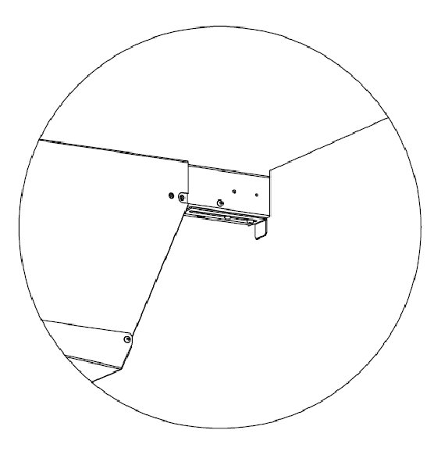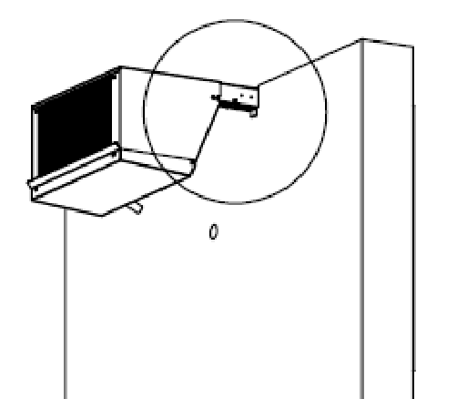

|  |  |  |
| --- | --- | --- |
| 3 |  | 4 |

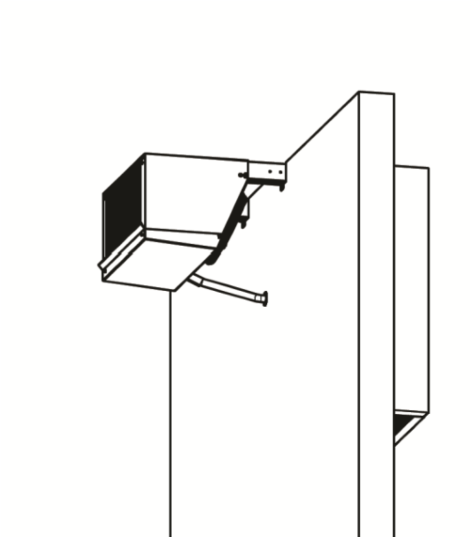

CONNECT THE CONDENSATE

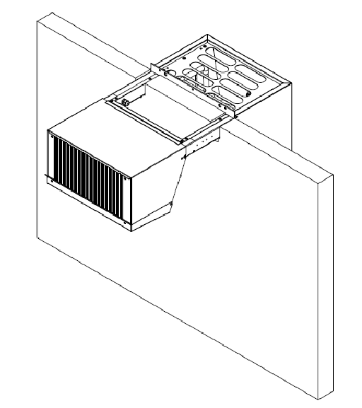

SEAL GAPS

DRAINING PIPE

Fig.11 Monoblock installation

The pad kit is an optional accessory to be purchased separately which allows the monoblock to be attached to the cell by means of a polyurethane foam panel. Check the compatibility of the panel with the dimensions of the machine purchased (see Tab.6).

**Mounting by use of the plugin kit:**

1. Attach the pad kit insulation panel to the machine.
2. Cut an opening in the cell wall of a size suitable for the dimension of the purchased unit and its respec- tive panel (see tab.4-5 for specific measurements according to the version and size of the unit).
3. Lift the machine safely with a suitable lifting device (forklift or other).
4. Place the machine on the cell wall by fitting the evaporator into the cut opening from the outside.
5. Seal the perimeter of the pad with a suitable sealant (silicone or other), compatible with the end use of

the cell, to prevent any infiltration of hot air inside the cell.

|  |  |  |  |  |  |  |  |  |  |
| --- | --- | --- | --- | --- | --- | --- | --- | --- | --- |
|  |  | **Panel KIT** | |  |  |  | **DIMENSION** | |  |
| **SIZE** | **SP 60 mm** | **SP 80 mm** | **SP 100 mm** | **SP 120 mm** | **SP 150 mm** | **O** | **P** | **Q** | **R** |
| **1** | KT/00191 | KT/00198 | KT/00194 | KT/00267 | KT/00270 | 455 | 500 | 460 | 510 |
| **2** | KT/00192 | KT/00199 | KT/00195 | KT/00268 | KT/00271 | 755 | 500 | 760 | 610 |
| **3** | KT/00193 | KT/00200 | KT/00196 | KT/00269 | KT/00272 | 755 | 600 | 760 | 610 |

Tab.6 Opening dimensions for the panel kit

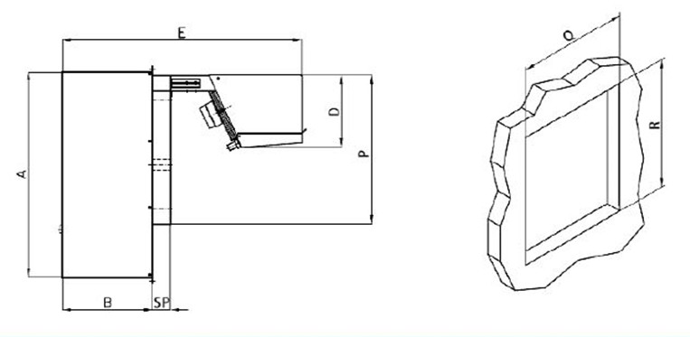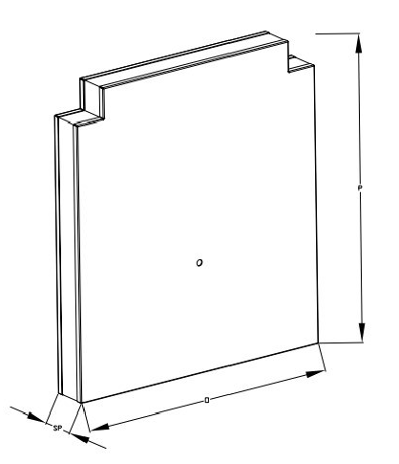

P

O

SP

Fig.12 Mounting of the panel kit

# 12. ELECTRICAL CONNECTION

The electrical connection has to be made by and under the responsibility of the customer.

The electrical power supply for the machine must be made in accordance with current standards and using suitable materials to ensure non-flammability.

The available power supply must be sufficient to properly feed the machine. Check that the network voltage rating corresponds with what is indicated on the nameplate of the monoblock.

Size the power supply cables correctly, so that the conductor cross-section is adequately sized for the current drawn by the machine.

Connection must be made using well laid power cables, without any loops or overlaps, placed in a protected position from possible accidental shock or damage. Keep cables away from liquids, water or heat sources. If cables are damaged, they must be replaced by qualified personnel.

Provide a suitably sized differential thermo-magnetic circuit breaker between the power line and the machine. UMZ size 1 versions are equipped with power cables complete with 16A European plug while the other versions are supplied with power cables without plugs.

**CAUTION: The connection of the machine to a grounding circuit is required by law.**

MTH S.r.l. will decline any responsibility if this requirement is not respected or if the electrical system to which the monoblock is connected is not realized in compliance with current standards.

For better availability of the system and to facilitate maintenance operations, the wiring diagram has been attached to the side of the electrical box, as shown in Fig.13.

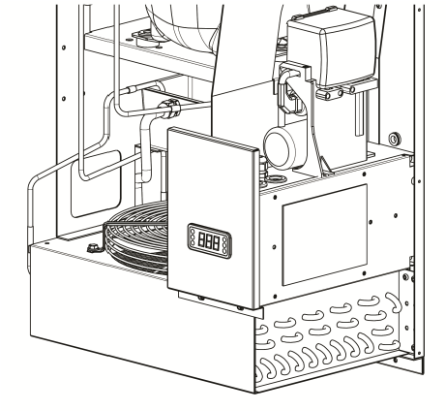

**CAUTION: Please note that before carrying out maintenance work on the electrical box, it is necessary to disconnect the machine from the power supply.**

Wiring diagrams of UMZ units are attached to the manual. The correspondence between the purchased monoblock model, wiring diagram,

WIRING DIAGRAM and maximum absorption of the unit can be read in the tables AN2 and

AN3 in the annex.

Fig.13 Location of the wiring diagram

# 13. STARTUP OF THE MONOBLOCK

**CAUTION: The refrigerated cell must be empty before proceeding with the installation and initial start-up of the machine.**

The Personnel in charge of the use and installation of the machine, must possess (or acquire by appropriate training and instruction) the requirements set forth below, and be, in addition, familiar with this manual and all information relating to safety:

* general and technical knowledge at a level sufficient to understand the contents of the manual;
* knowledge of the main hygiene, accident prevention and technological regulations.

Before putting into operation, it is necessary to carry out a series of checks and controls in order to prevent errors or accidents during the start-up phase.

* check for evidence of damage during the assembly phase;
* check, very carefully, the integrity of the control panel, electrical cables and piping;
* check the exact connection of all external power sources; • check the free movement and free rotation of all moving parts (fans, etc.).

**CAUTION: If the equipment was accidentally placed upside down during transport, wait about 2 hours after it** **has been positioned vertically before starting it up.**

Temperature should be chosen by considering:

* the type of product to be stored in the cell;
* the ambient temperature; • the frequency of door opening.

Keep in mind, that negative temperature cells (-10°C/-25°C) are suitable for storing frozen products for long periods and for freezing small quantities of small sized fresh goods.

In any case, before loading the product wait until the cell has reached temperature by checking it on the onboard thermometer. If you have short interruptions in the power supply it is likely that the compressor will restart with some delay, This is perfectly normal.

**CAUTION: During the initial start-up operation, it is advisable (especially for low-temperature cells) to initially set an intermediate working temperature and perform manual defrost at approximately 2-hour intervals to allow cleaning of accumulated condensate on the evaporator.**

# 14. OPERATION OF THE MACHINE

UMZ monoblock is a refrigeration system operated by a hermetic reciprocating compressor, powered by electricity (single-phase or three-phase). Depending on the model, the refrigerant gas used can be R452A or R290, this fluid flows in a sealed circuit inside the machine

During normal operation of the monoblock, refrigerant in liquid phase circulates through the evaporator located inside the refrigerated cell. The fluid extracts heat from the environment inside the cold room, cooling the air and allowing the refrigerant to change state from liquid to vapor. The fluid flows into the condenser unit installed outside the cold room, where it undergoes a compression process. Through the condenser, the refrigerant releases heat to the external environment and returns to a liquid state. The last step in the refrigeration cycle is lamination, which consists in causing a pressure drop and preparing the refrigerant to return to the evaporator and begin a new cycle.

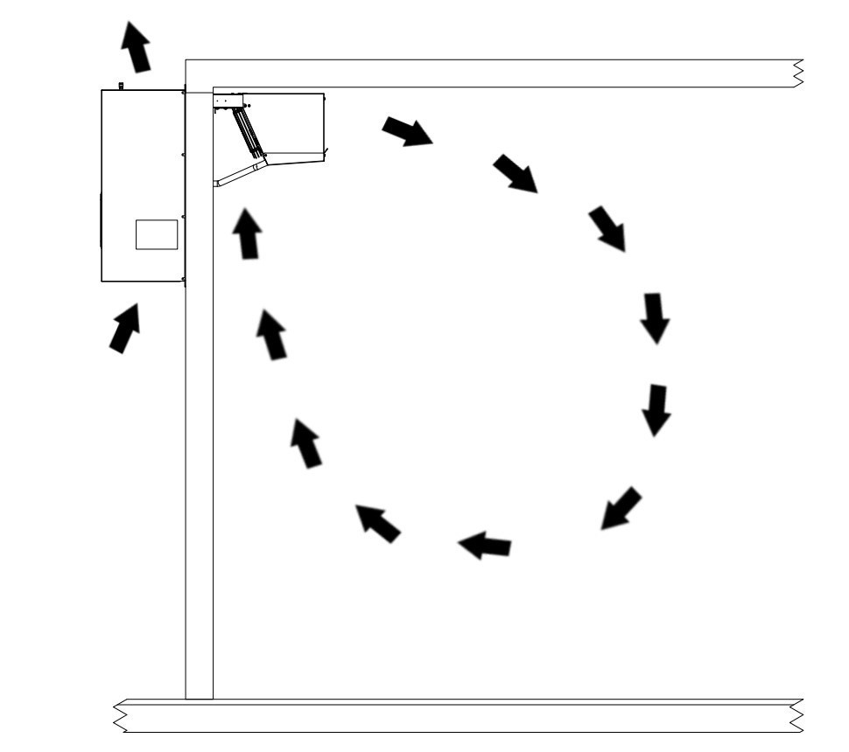

CONDENSING UNIT

(

OUTSIDE OF THE CELL

)

EVAPORATING UNIT

(

INSIDE THE CELL

)

Fig.14 Operation of the machine and direction of the air flow

# 15. USER INTERFACE AND CONTROL LOGIC

The UMZ monoblock is equipped with the **Dixell XR70CH** multifunction controller.

This device allows to adjust the temperature inside the cell, perform manual defrosting, and display the operating parameters of the monoblock. The main setting parameters of this controller are shown in the table below;

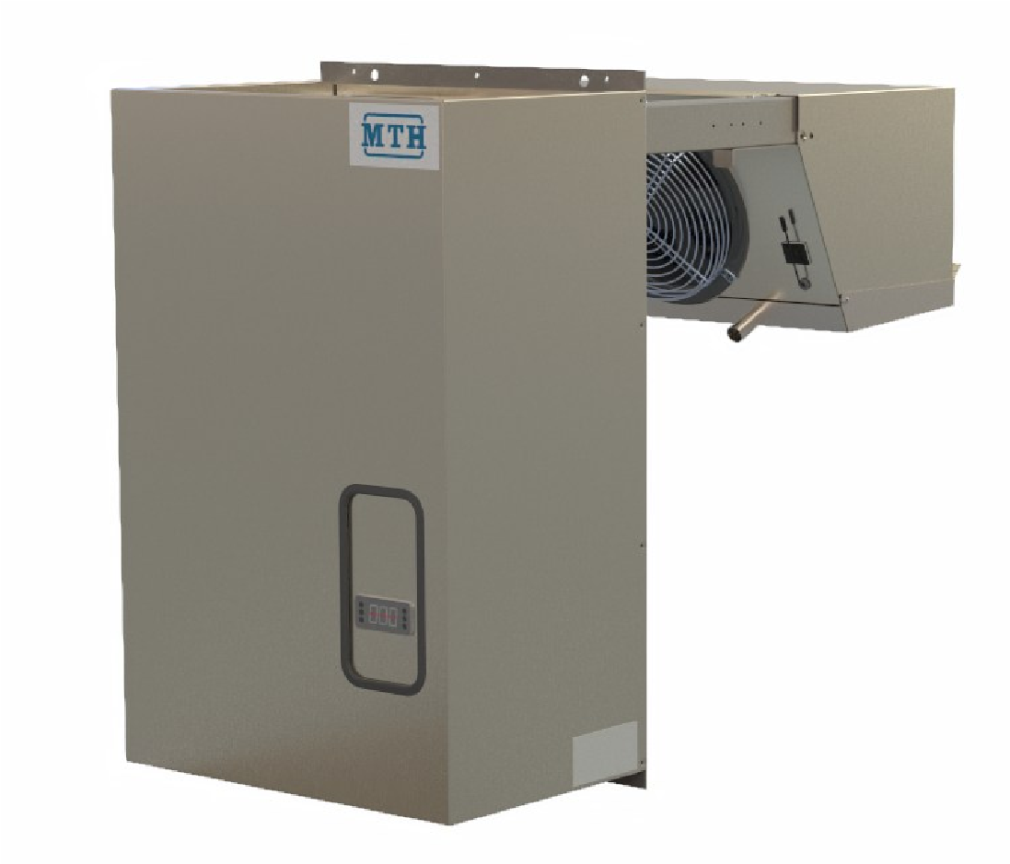

Fig.15 V2 version with controller Dixell XR70CH

Fig.16 shows the quadrants and main controls of the two Dixell controllers, together with instructions for performing some simple operations (change set point temperature, perform manual defrost).

The parameters for setting the controllers depending on the monoblock version purchased, the refrigerant fluid used in the cycle and the defrosting methodology implemented on the machine, are attached to the manual.

Additional information regarding the setting of the machine control logic can be found in the Dixell controller instruction manual, available on the manufacturer's website.

**CAUTION: Changing the setting parameters of the supplied controller will invalidate the warranty claim. The buyer or user may only change the temperature set point and defrost interval (IdF).**

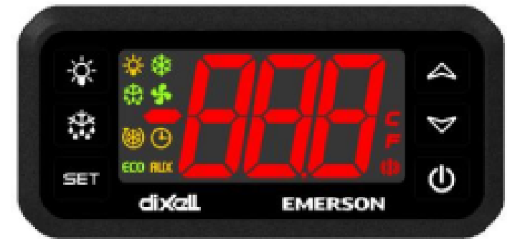

Fig.16 Interface of the controller Dixell XR70CH

|  |  |  |  |  |  |  |  |  |
| --- | --- | --- | --- | --- | --- | --- | --- | --- |
| **KEY** | | | | **FUNCTION** | | | | |
|  | | | | To display target set point; in programming mode it selects a parameter or confirm an operation. | | | | |
|  | | | | (DEF) To start a manual defrost. | | | | |
|  | | | | (UP) To see the max stored temperature; in programming mode it browses the parameter codes or increases the displayed value. | | | | |
|  | | | | (DOWN) To see the min stored temperature; in programming mode it browses the parameter codes or decreases the displayed value. | | | | |
|  | | | | To switch the instrument on and off (when onF=oFF). | | | | |
|  | | | | To switch on and off the light (when oA3=LiG). | | | | |
|  | | | | **KEY COMBINATION** | | | | |
|  | | | | To lock & unlock the keyboard. | | | | |
|  | | | | To enter in programming mode. | | | | |
|  | | | | To return to the room temperature display. | | | | |
|  | | |  | | | | **USE OF LEDS** |  |
| **LED** | | | **MODE** | | | |  | **FUNCTION** |
|  | | | ON | | | | Compressor enabled |  |
|  | | | FLASHING | | | | Anti-short cycle delay enabled |  |
|  | | | ON | | | | Defrost enabled |  |
|  | | | FLASHING | | | | Drip time in progress |  |
|  | | | ON | | | | Fans enabled | | | | |
|  | | | FLASHING | | | | Fans delay after defrost in progress | | | | |
|  | | | ON | | | | An alarm is occurring | | | | |
|  | | | ON | | | | Continuous cycle is running | | | | |
|  | | | ON | | | | Energy saving enabled | | | | |
|  | | | ON | | | | Light on | | | | |
|  | | | ON | | | | Auxiliary relay on | | | | |
|  | | | ON | | | | Measurement unit | | | | |
|  | | | FLASHING | | | | Programming phase | | | | |
| **HOW TO: SEE THE SET POINT** | | | | | | | | | | | |
|  | | | | | 1. Push and immediately release the SET key: the display will show the Set point value. 2. Push and immediately release the SET key or wait for 5 sec to display the probe value again. | | | | | | |
|  | | | | | **HOW TO CHANGE THE SET POINT** | | | | | | |
| 1. Push the | | | | | SET key more than 2 sec to change the Set point value. | | | | | | |
| 2. The value | | | | | of the set point will be displayed and the “°C” or “°F” LED will start blinking. | | | | | | |
| 3. To change | | | | | the Set value push the UP or DOWN arrows within 10 sec. | | | | | | |
| 4. To save th | | | | | e new set point value, push the SET key again or wait for 10 sec | | | | | | |
|  | | | | | **HOW TO START A MANUAL DEFROST** | | | | | | |
|  | | | | | Push the DEF key for more than 2 sec and a manual defrost will start. | | | | | | |

Tab.7 Main function of the controller Dixell XR70CH

|  |  |  |  |  |
| --- | --- | --- | --- | --- |
| **Setting parameters** | | | | |
| **UMZ Monoblocks equipped with Dixell XR70CH - Hot gas defrost** | | | | |
| **Label** | **Name** | **Level** | **REGULATION** | |
| ***MBP*** | ***LBP*** |
| **Set** | **Set point** | **Pr1** | **min -5** | **min -25** |
| **Hy** | **Differential** | **Pr1** | **2** | **2** |
| LS | **Minimum set point** | Pr2 | -5 | -25 |
| US | **Maximum set point** | Pr2 | 15 | 0 |
| **Ot** | **Thermostat probe calibration** | **Pr1** | **0** | **-2** |
| **P2P** | **Evaporator probe presence** | **Pr1** | **Y** | **Y** |
| oE | **Evaporator probe calibration** | Pr2 | 0 | 0 |
| P3P | **Third probe presence** | Pr2 | n | n |
| o3 | **Third probe calibration** | Pr2 | 0 | 0 |
| P4P | Fourth probe presence | Pr2 | n | n |
| o4 | Fourth probe calibration | Pr2 | 0 | 0 |
| OdS | Outputs delay at start up | Pr2 | 0 | 0 |
| **AC** | **Anti-short cycle delay** | **Pr1** | **1** | **1** |
| rtr | P1-P2 percentage for regulation | Pr2 | 100 | 100 |
| CCt | Continuous cycle duration | Pr2 | 0 | 0 |
| CCS | Set point for continuous cycle | Pr2 | -5 | -25 |
| COn | Compressor ON time with faulty probe | Pr2 | 15 | 15 |
| COF | Compressor OFF time with faulty probe | Pr2 | 15 | 15 |
|  |  |  | ***DISPLAY*** | |
| CF | Temperature measurement unit | Pr2 | °C | °C |
| **rES** | Resolution | **Pr1** | **dE** | **dE** |
| Lod | Probe displayed | Pr2 | P1 | P1 |
| dLy | Display temperature delay | Pr2 | 0 | 0 |
| dtr | P1-P2 percentage for display | Pr2 | 50 | 50 |
|  |  |  | ***DEFROST*** | |
| **tdF** | **Defrost type** | **Pr1** | **in** | **in** |
| dFP | Probe selection for defrost termination | Pr2 | P2 | P2 |
| **dtE** | **Defrost termination temperature** | **Pr1** | **6** | **0** |
| **IdF** | **Interval between defrost cycles** | **Pr1** | **6** | **4** |
| **MdF** | **(Maximum) length for defrost** | **Pr1** | **30** | **35** |
| dSd | Start defrost delay | Pr2 | 0 | 0 |
| dFd | Displaying during defrost | Pr2 | DEF | DEF |
| dAd | MAX display delay after defrost | Pr2 | 6 | 6 |
| Fdt | Draining time | Pr2 | 4 | 2 |
| dPO | First defrost after start-up | Pr2 | N | N |

|  |  |  |  |  |
| --- | --- | --- | --- | --- |
| **Label** | **Name** | **Level** | **REGULATION** | |
| ***MBP*** | ***LBP*** |
| dAF | Defrost delay after fast freezing | Pr2 | ***0*** | ***0*** |
|  |  |  | ***FANS*** | |
| **FnC** | **Fan operating mode** | **Pr1** | **C-n** | **C-n** |
| **Fnd** | **Fan delay after defrost** | **Pr1** | **4** | **4** |
| FCt | Differential of temperature for forced activation of fans | Pr2 | 0 | 0 |
| **FSt** | **Fan stop temperature** | **Pr1** | **15** | **3** |
| Fon | Fan on time with compressor on | Pr2 | 1 | 0 |
| Foff | Fan off time with compressor off | Pr2 | 1 | 0 |
| FAP | Probe selection for fan management | Pr2 | P2 | P2 |
|  |  |  | ***ALARMS*** | |
| ALC | Temperat. alarms configuration | Pr2 | RE | RE |
| **ALU** | **MAXIMUM temperature alarm** | **Pr1** | **20** | **15** |
| **ALL** | **Minimum temperature alarm** | **Pr1** | **20** | **15** |
| AFH | Differential for temperat. alarm recovery | Pr2 | 2 | 2 |
| ALd | Temperature alarm delay | Pr2 | 15 | 15 |
| dAO | Delay of temperature alarm at start up | Pr2 | 2 | 2 |
|  |  |  | ***CONDENS. ALARM*** | |
| AP2 | Probe for temperat. alarm of condenser | Pr2 | P4 | P4 |
| AL2 | Condenser for low temperat. alarm | Pr2 | -40 | -40 |
| AU2 | Condenser for high temperat. alarm | Pr2 | 110 | 110 |
| AH2 | Differ. for condenser temp. alar. recovery | Pr2 | 5 | 5 |
| Ad2 | Condenser temperature alarm delay | Pr2 | 15 | 15 |
| dA2 | Delay of cond. temper. alarm at start up | Pr2 | 2 | 2 |
| bLL | Compr. off for condenser low temperature alarm | Pr2 | n | n |
| AC2 | Compr. off for condenser high temperature alarm | Pr2 | n | n |
|  |  |  | ***FOURTH RELAY*** | |
| tbA | Alarm relay disabling | Pr2 | Y | Y |
| oA3 | Fourth relay configuration | Pr2 | Lig | Lig |
| AoP | Alarm relay polarity (oA3=ALr) | Pr2 | cL | cL |
|  |  |  | ***DIGITAL INPUTS*** | |
| **i1P** | **Alarm relay polarity** | **Pr1** | **CL** | **CL** |
| **i1F** | **Digital input configuration** | **Pr1** | **dor** | **dor** |
| **did** | **Digital input alarm delay** | **Pr1** | **5** | **5** |
| nPS | Number of activation of pressure switch | Pr2 | 15 | 15 |
| Odc | Compress and fan status when open door | Pr2 | F-C | F-C |
| rrd | Regulation restart with door open alarm | Pr2 | Y | Y |
| **Label** | **Name** | **Level** | **REGULATION** | |
| ***MBP*** | ***LBP*** |
| HES | Differential for Energy Saving | Pr2 | 0 | 0 |
|  |  |  | ***OTHER*** | |
| Adr | Serial address | Pr2 | 1 | 1 |
| **Pbc** | **Kind of probe** | **Pr1** | **ntc** | **ntc** |
| onF | on/off key enabling | Pr2 | OFF | OFF |
| dP1 | Room probe display | Pr2 | --- | --- |
| **dP2** | **Evaporator probe display** | **Pr1** | **---** | **---** |
| **dP3** | **Third probe display** | **Pr1** | **---** | **---** |
| **dP4** | **Fourth probe display** | **Pr1** | **---** | **---** |
| rSE | Real set | Pr2 | --- | --- |
| rEL | Software release | Pr2 | --- | --- |
| Ptb | Map code | Pr2 | --- | --- |
| Prd | Probes display | Pr2 | --- | --- |

Tab. 8 Parameters of the controller Dixell XR70CH Hot gas defrost

# 16. FOOD STORAGE

In order to achieve the best performance of the refrigerator, the following guidelines should be followed: • do not introduce any hot food or uncovered liquids inside the cell;

* wrap foods or protect them in other ways, especially if they contain flavorings or cream:
* arrange food inside the cabinet so that air circulation is not restricted by unnecessary obstructions;
* avoid frequent and prolonged opening of doors as much as possible;
* wait a few moments before re-opening the door once it has been closed.

# 17. FOOD PRESERVATION

The main cause of the degradation of food and organic substances in general is the proliferation of bacteria contained in the cells that constitute the food itself. The production of bacteria can be greatly slowed down by lowering the temperature of the product, in fact, each product, according to its organoleptic characteristics, needs suitable temperatures and environmental conditions.

In order to benefit in the best possible way from the equipment purchased, it is advisable to pay attention to the:

* freezing point,
* characteristics and conservation information of some frozen products.

|  |  |
| --- | --- |
| **FOOD TYPE** | **STORAGE TEMPERATURE (°C)** |
| Fish | +0 / +4 |
| Meats | +2 / +4 |
| Poultry | +1 / +4 |
| Vegetables | +4 / +10 |
| Fruit | +4 / +8 |
| Eggs and egg products | +6 / +8 |
| Pasteurised milk and fresh dairy products | +2 / +6 |
| Cold meats and cheeses | +4 / +8 |
| Frozen meat | -12 |
| Ice cream | -20 |
| Frozen food | -18 |

Tab.9 Indicative food storage temperatures

# 18. ORDINARY MAINTENANCE

In order to ensure full efficiency and safety of the machine, it is necessary to carry out regular maintenance and cleaning. Preventive maintenance carried out correctly and within the recommended timeframe extends the overall functionality of the machine over time, and also ensures safety for operators and maintenance staff.

**CAUTION: All operations to be performed on the machine must always be carried out by qualified techni-cians, wearing all the necessary personal protective equipment, using standardised working tools and com-plying with all applicable safety regulations.**

**CAUTION: Before carrying out any work on the machine, it is necessary to switch it off, disconnect it from the power supply by acting on the circuit breaker and wait until there are no moving parts and hot surfaces have cooled down. It is absolutely forbidden to remove the safety guards to carry out routine maintenance work without first disconnecting the machine from the power supply. The manufacturer accepts no liability for accidents resulting from failure to comply with this obligation.**

Do not use solvents or flammable fluids to clean the components, but use only approved non-flammable, nontoxic and non-corrosive cleaning agents. Clean the finned packs (condenser and evaporator) with an air jet or dry stiff bristle brush and/or brush, removing dust and lint deposited on the fins with a vertical movement.

The machines containing flammable refrigerant (R290) are supplied with a factory sealed refrigerant circuit; any intervention on it is therefore strictly forbidden. In the event of problems with the refrigeration system, themachine must be returned to the manufacturer.

Do not tamper with the machine and do not apply transformations, variations or replacement of components with non-serial components without written authorisation from the manufacturer.

It is essential to reposition all fixed guards upon completion of the maintenance operations listed below.

The main ordinary maintenance operations are the following ones:

* CLEANING OF EXTERNAL PARTS:

Clean the external parts of the machine weekly with a damp cloth and using only approved nonflammable, non-toxic, non-corrosive and non-abrasive neutral detergents (do not use solvents). Check the integrity of electrical cables and parts;

**CAUTION: Presence of sharp components, use protective gloves avoiding direct contact with sharp surfaces or any hot surfaces;**

* CLEANING THE CONDENSER:

Clean the condenser by removing dust and grease periodically and at least once a month. If the machine operates in a very dusty environment, carry out cleaning operations more frequently. Failure to periodically clean the finned condenser pack would increase the risk of condenser clogging and compromise the efficiency of the refrigeration system. Verify that there are no refrigerant leaks by visually checking the entire refrigerant circuit. Leaks are generally indicated by the presence of lubricant.

**CAUTION: Presence of sharp components, use protective gloves avoiding direct contact with sharp surfaces or any hot surfaces;**

* CLEANING THE EVAPORATOR UNIT:

Once a month, visually check the integrity of the refrigerant circuit in the evaporating part by checking for refrigerant leaks. Generally, any leaks are evidenced by the presence of lubricant. Also check the correct functioning of the condensate drain in the collection tray and the absence of a thick layer of ice in the evaporating pack. If the evaporating pack is dirty, the food must be temporarily moved from the cabinet and cleaned.

**CAUTION: Presence of sharp components, use protective gloves avoiding direct contact with sharp surfaces or any hot surfaces;**

* CONDENSATION WATER DISCHARGE:

Regularly check that the condensation water drain is not clogged and that the drain heater is working properly.

# 19. EXTRAORDINARY MAINTENANCE AND REPAIRS

Extraordinary maintenance and repairs are tasks reserved exclusively for specialised personnel authorised by the manufacturer.

No liability is accepted for work carried out by the user, by unauthorised personnel or for the use of non-original or unsuitable spare parts.

The table shows the most frequent faults, their possible causes and remedies:

|  |  |  |  |  |
| --- | --- | --- | --- | --- |
| **FAULT DESCRIPTION** | **POSSIBLE CAUSE** | | **REMEDY** | |
| Compressor does not start and does not make sound | 1. Thermal protection tripped 2. Lack of voltage 3. Electrical connections loose or incorrect | | 1. Check electrical connections 2. Check the power supply line 3. Check and tighten the electrical connections according to the wiring scheme | |
| The compressor does not start and the thermal protector trips | 1. Improper electrical connections 2. Low voltage at the compressor 3. Failure of starting capacitor 4. Relay blocked 5. Electric motor with damaged winding | | 1. Check electrical connections and rewire 2. Identify cause and eliminate 3. Identify cause and change capacitor 4. Replace relay and identify cause 5. Replace compressor | |
| Compressor starts but relay does not open | 1. Improper electrical connections 2. Low voltage at the compressor 3. Relay blocked 4. Too high discharge pressure 5. Electric motor with damaged winding | | 1. Check electrical connections and rewire 2. Identify cause and eliminate it 3. Replace relay and identify cause 4. Identify cause and eliminate 5. Replace compressor | |
| Thermal protector activated | 1. Low voltage on the compressor (or unbalanced phases for three-phase motors) 2. Failure of the thermal protector 3. Failure of the run capacitor 4. Discharge pressure too high 5. Suction pressure too high 6. Compressor overheated, hot return gas 7. Electric motor with damaged winding | | 1. Identify cause and eliminate it 2. Verify characteristics and replace if necessary 3. Identify cause and change capacitor 4. Check for obstructions in the circuit of the system 5. Check condensing unit sizing, replace if necessary 6. Check refrigerant charge and the presence of any leaks. If necessary, add gas up to the amount indicated on the label 7. Replace compressor | |
| Compressor works only with short cycles | 1. Thermal protector tripped 2. Incorrectly set thermostat | | 1. Identify cause (see previous point) 2. Adjust settings | |
| **FAULT DESCRIPTION** | | **POSSIBLE CAUSE** | | **REMEDY** | |
| The refrigerating unit runs continuously but does not reach the setting temperature. | | 1. Lack of air circulation 2. Condenser clogged 3. Insufficient refrigerant 4. System under-dimensioned compared the load 5. Insufficient insulation or compromised   door seal   1. Frosted evaporator 2. System circuit restriction | | 1. Ventilate more 2. Clean the condenser 3. Contact technical assistance 4. Replace the monoblock with a higher capacity one 5. Check insulation and gaskets 6. Perform a manual defrost 7. Identify restriction and remove it | |
| Too high cell temperature | | 1. Thermostat wrongly set 2. Undersized expansion valve 3. Undersized evaporator | | 1. Set the thermostat correctly 2. Replace with a suitable valve 3. Contact technical assistance | |
| Ice buildup on the evaporator | | 1. Improper use 2. Control panel failure | | 1. Stick to the use specified in this manual 2. Contact technical assistance | |
| Frosted suction piping | | 1. Expansion valve stuck open 2. Evaporator fan not working 3. Excessive gas charge | | 1. Clean the valve, adjust it properly or replace it 2. Identify cause and eliminate 3. Check refrigerant charge | |
| Water or ice stagnation in the drip tray | | 1. Clogged drain 2. Machine not levelled | | 1. Clean the spill and drain 2. Check that the appliance is levelled | |
| The appliance is noisy | | 1. Machine not levelled 2. Contact of external objects 3. Loose screws and bolts | | 1. Check that the unit is levelled 2. Check that no pipes or fan blades are in contact with foreign objects 3. Tighten loose bolts and screws | |

Tab.10 Main machine faults and possible solutions

# 20. RECYCLING AND DISPOSAL

When equipment stops working and must be scrapped, care should be taken to ensure that its disposal causes the least environmental damage. Proper disposal of obsolete equipment helps prevent possible negative consequences on human health and the environment .

For more detailed information on the disposal of obsolete equipment, contact the municipality, waste disposal service or retailer where the product was purchased.

**CAUTION: the refrigerant must not be discharged into the atmosphere, it must be recovered and disposed of by companies authorised to collect special waste.**

**CAUTION: presence of flammable refrigerant in the refrigeration system. Exercise extreme caution and do not force or tamper with the partly completed machine. For installation, handling, maintenance and/or disposal operations, rely on authorised professionals, who must take all the safety measures required by local rules and regulations.**

# 21. WARRANTY TERMS

1. In these conditions of guarantee, the term "products" means the products described and offered currently and in the future by the Seller in its catalogues, price lists, etc.
2. The operation of the refrigerating equipment is guaranteed for twelve months from the delivery date to the Buyer. The transport document will attest the valid date. The warranty period ends 12 months after the supply even if the products have not been put in service for any reason.
3. The warranty covers only repairs or replacements of those parts of the device that, as incontestably deter-

mined by the Seller, may be imperfect for defects in material or manufacturing; therefore it does not include in any case the paint and the chrome (which, despite being realized in a workmanlike manner, have a duration resulting directly by the care of the Buyer) glass parts, plastic parts, removable parts, electrical components and in general all the fragile parts and / or the ones not related to the functioning of the machine. The Seller assumes no responsibility in case its products do not match the national regulations and / or the technical standards of the country of installation, but only guarantees for the compliance of its products to the standards required by Italian law.

1. The Seller is never required to replace the equipment, or to compensate damages to the product stored, and in general for all consequential damages, except those for which it is civilly liable under the law.
2. The warranty claim expires and therefore any interventions by MTH technicians or those commissioned by it, will be charged if even one of the following circumstances occurs:
   1. breaking of tamper-resistant seals placed by MTH S.r.l.;
   2. damage resulting from force majeure in general or occurring during transport: delivery is made EXW (Incoterms of the ICC); responsibility for these damages is of the carrier, and therefore to the same must be contested upon receipt. Likewise, any damage resulting from improper installation or maintenance of the equipment will not be accepted as a valid issue of contestation for warranty purposes;
   3. installation of the machine in different conditions from those specified in this manual;
   4. connection to the electrical and/or plumbing network through a system of insufficient capacity or that does not comply with current regulations. In particular, reference is made to the technical regulations and good engineering practices relating to the ground connection of equipment;
   5. lack of operation due to power failure, grid voltage variations, or similar accidents and resulting failures;
   6. failures due to accidental breakage (by way of example but not limited to: disconnected plugs, blown fuses), and other inconveniences resulting in any case from external factors and from the Buyer's negligence;
   7. any disassembly, modification or tampering of the machine or its components performed by the user or unauthorized personnel;
   8. use of spare parts that are not original or not specified by MTH S.r.l;
   9. use in violation of what is specified by the regulations in force in the country of use;
   10. destination of the equipment for uses other than those for which it was prepared;
   11. use of the appliance in a manner not in accordance with the contents of this Operation and Maintenance Manual;
   12. total or partial non-observance of the instructions in this Manual;
   13. missing or incorrect maintenance;
   14. changing the setting parameters of the supplied controller; the Buyer or user may only change the temperature set point and defrost interval (IdF).
3. The warranty is suspended, maintaining valid the final expiration after twelve month from the delivery, in case of default by the Purchaser even of only one condition of supply.
4. Repairs and / or replacements of parts will not lead to an extension of the term of the warranty. If, for technical reasons, the repair could not be carried out on site the equipment must be returned to the Seller who will repair it and send it back to the customer charging the transport costs.
5. Requests of a technical intervention must be send directly to the Seller providing all the necessary details for an exact evaluation of the defect. The Purchaser cannot claim against the Seller if it has not sent a written communication within the irrevocable term of eight days from the date of discovery of the defect.
6. When the warranty expires, if the Purchaser needs a repair and / or a replacement, will be charged the expenses related to the spare parts used, the cost of labor, transport of materials and travel costs, according to the rates in force.
7. The warranty excludes the travel costs of the staff (hours of travel, accommodation and meals) which will always be at expense of the user.
8. These Warranty Conditions will be interpreted and governed according to the Italian Law.

**IMPORTANT:**

To exercise the warranty right, the Buyer must submit to the Seller:

* 1. WARRANTY CERTIFICATE;
  2. one of the following documents evidencing the date of delivery: INVOICE, TRANSPORT DOCUMENT. The absence of one of the documents does not allow to assess the validity of the warranty and therefore the intervention will be considered at the expense of the Buyer and charged to the same;
  3. the Buyer must provide the unit and all electrical cables and accessories supplied with the machine.

These accessories must be in integral condition or the warranty will be invalidated;

* 1. the customer must provide the unit with the seals placed by MTH S.r.l. undamaged. The warranty NEVER includes interventions of staff required for :
  + The installation;
  + The control and / or the adjustments;
  + The explanations for the use;
  + The modification of the doors’ opening;
  + The normal maintenance;

The interventions of this kind will be at expense of the Buyer.

The warranty conditions are those specified on the certificate. Any extension is responsibility of the person who has granted it putting in writing and do not ever commit the Seller.

# ALLEGATI - ANNEXES

### SCHEMA IMPIANTO FRIGORIFERO - PIPING AND INSTRUMENTATION DIAGRAM

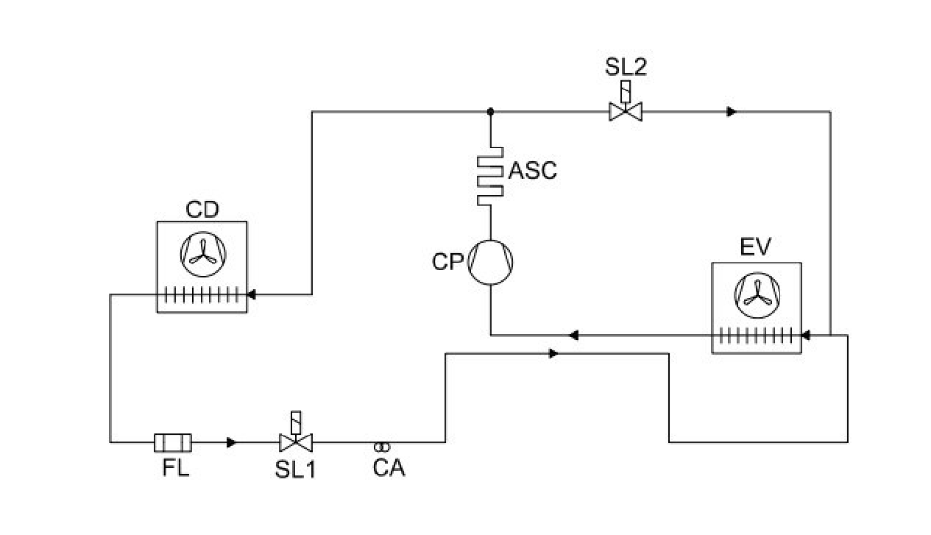

Fig. AN1 - Versione R290 sbrinamento a gas caldo - R290 hot gas defrost version

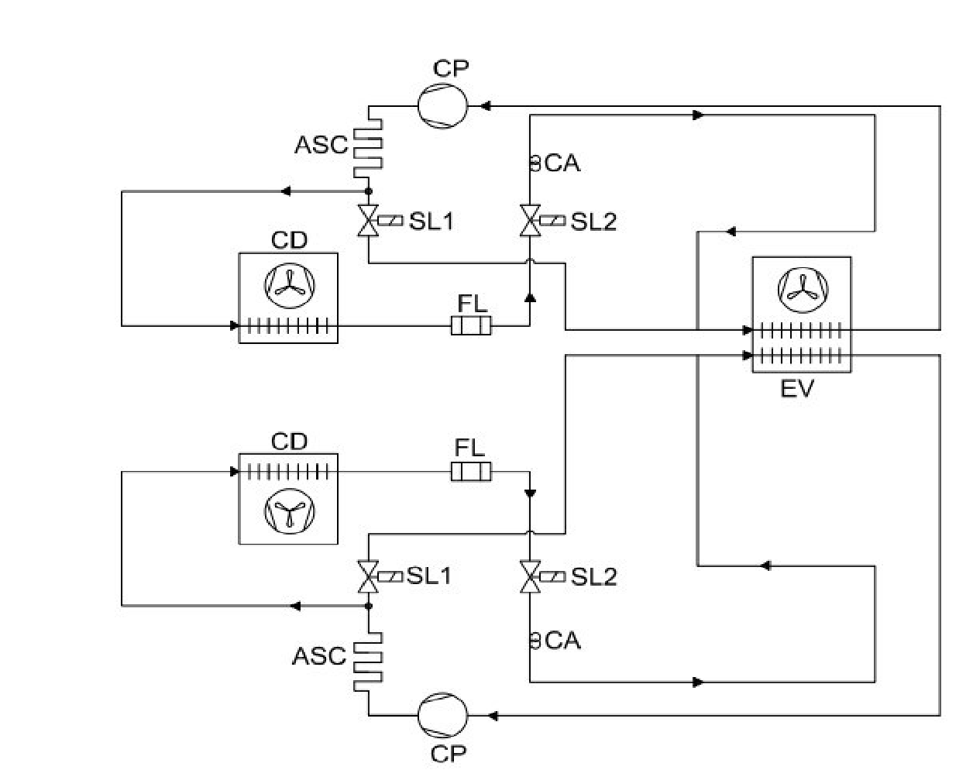

Fig. AN2 - Versione R290 doppio circuito sbrinamento a gas caldo - R290 double circuit hot gas defrost version

|  |  |  |  |
| --- | --- | --- | --- |
| **LEGENDA - KEY LEGEND** | | | |
| **CD** | **CONDENSATORE - CONDENSER** | **SL2** | **VALVOLA SOLENOIDE GAS CALDO - HOT GAS**  **SOLENOID VALVE** |
| **CP** | **COMPRESSORE - COMPRESSOR** | **EV** | **EVAPORATORE - EVAPORATOR** |
| **FL** | **FILTRO DEIDRATATORE - DRIER FILTER** | **CA** | **CAPILLARE - CAPILLARY** |
| **SL1** | **VALVOLA SOLENOIDE LIQUIDO - LIQUID SOLENOID VALVE** | **ASC** | **SERPENTINA EVAPORA CONDENSA - CONDENSATION DRYER** |

### FIG. AN3 DIMENSIONI D’INGOMBRO DELLA MACCHINA - OVERALL DIMENSION OF THE MACHINE

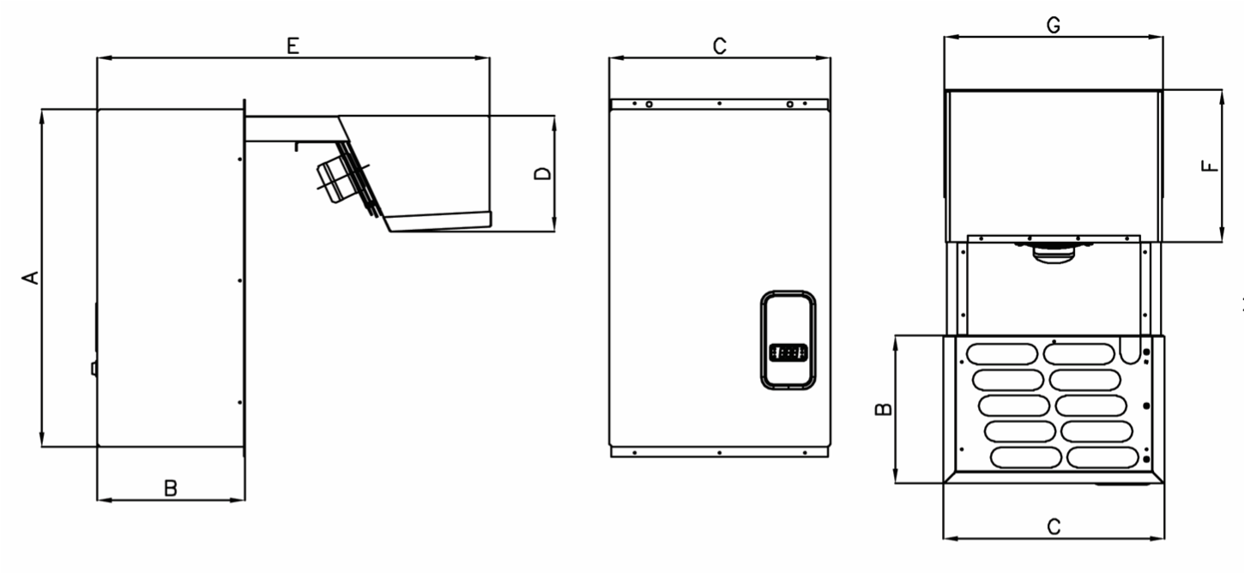

Le frecce indicano il senso di circolazione dell’aria - Arrows indicate the direction of air circulation

|  |  |  |  |  |  |  |  |  |  |
| --- | --- | --- | --- | --- | --- | --- | --- | --- | --- |
| **UMZ LBP** | | | | | | | | |  |
| **CODICE MTH MTH CODE** | **TAGLIA SIZE** | **VERSIONE CARPENTERIA CARTER VERSION** | **DIMENSIONE MONOBLOCCO MONOBLOCK DIMENSION [mm]** | | | | | |  |
| **A** | **B** | **C** | **D** | **E** | **F** | **G** |
| **19135030** | **1** | **\*V2** | **700** | **305** | **455** | **245** | **810** | **320** | **445** |
| **19135031** | **1** | **\*\*V2 - T150** | **700** | **305** | **455** | **245** | **860** | **320** | **445** |
| **19135040** | **1** | **\*V2** | **700** | **305** | **455** | **245** | **810** | **320** | **445** |
| **19135041** | **1** | **\*\*V2 - T150** | **700** | **305** | **455** | **245** | **860** | **320** | **445** |
| **19135080** | **2** | **\*V2** | **700** | **305** | **755** | **245** | **810** | **320** | **745** |
| **19135081** | **2** | **\*\*V2 - T150** | **700** | **305** | **455** | **245** | **860** | **320** | **445** |
| **19135131** | **3** | **\*V2** | **800** | **420** | **755** | **420** | **1060** | **400** | **745** |
| **19135131** | **3** | **\*\*V2 - T150** | **800** | **420** | **755** | **420** | **1110** | **400** | **745** |

Tab AN1 - UMZ LBP Dimensioni d’ingombro della macchina - UMZ LBP Overall dimensions of the machine

|  |  |  |  |  |  |  |  |  |  |
| --- | --- | --- | --- | --- | --- | --- | --- | --- | --- |
| **UMZ MBP** | | | |  | | | | |  |
| **CODICE MTH MTH CODE** | **TAGLIA SIZE** | **VERSIONE CARPENTERIA CARTER VERSION** |  | **DIMENSIONE MONOBLOCCO MONOBLOCK DIMENSION [mm]** | | | | |  |
| **A** | **B** | **C** | **D** | **E** | **F** | **G** |
| **19131040** | **1** | **\*V2** | **700** | **305** | **455** | **245** | **810** | **320** | **445** |
| **19131041** | **1** | **\*\*V2 - T150** | **700** | **305** | **755** | **245** | **860** | **320** | **445** |
| **19131050** | **1** | **\*V2** | **700** | **305** | **455** | **245** | **810** | **320** | **445** |
| **19131051** | **1** | **\*\*V2 - T150** | **700** | **305** | **755** | **245** | **860** | **320** | **445** |
| **19131090** | **2** | **\*V2** | **700** | **305** | **755** | **245** | **810** | **320** | **745** |
| **19131091** | **2** | **\*\*V2 - T150** | **700** | **305** | **755** | **245** | **860** | **320** | **445** |
| **19131120** | **2** | **\*V2** | **700** | **305** | **755** | **245** | **810** | **320** | **745** |
| **19131121** | **2** | **\*\*V2 - T150** | **700** | **305** | **755** | **245** | **860** | **320** | **445** |
| **19131180** | **3** | **\*V2** | **800** | **420** | **755** | **420** | **1060** | **400** | **745** |
| **19131181** | **3** | **\*\*V2 - T150** | **800** | **420** | **755** | **420** | **1110** | **400** | **745** |

Tab AN2 - UMZ MBP Dimensioni d’ingombro della macchina - UMZ MBP Overall dimensions of the machine

*Versione carpenteria **V2** adatta a celle di spessore fino a 100mm -**V2** frame version suitable for cell thicknesses up to 100mm

**Versione carpenteria **V2-T150** adatta a celle di spessore fino a 150mm - **V2-T150** frame version suitable for cells up to 150mm thick

|  |  |  |  |  |  |  |
| --- | --- | --- | --- | --- | --- | --- |
| **Tab. AN3 - UMZ LBP** | | | | |  | |
| **CODICE MTH MTH CODE** | **MODELLO**  **MODEL** | **SCHEMA ELETTRICO**  **ELECTRIC SCHEME** | **ASSORBIMENTO MAX [A] MAX ABSORPTION [A]** | | **N° CIRCUITI**  **N°CIRCUITS** | |
| **19135030** | **UMZU/03S1** | **1913EL01** | **6.07** | | **1** | |
| **19135031** | **UMZU/03S1** | **1913EL01** | **6.07** | | **1** | |
| **19135040** | **UMZU/04A1** | **1913EL01** | **6.14** | | **1** | |
| **19135041** | **UMZU/04A1** | **1913EL01** | **6.14** | | **1** | |
| **19135080** | **UMZU/08S2** | **1913EL02** | **12.14** | | **2** | |
| **19135081** | **UMZU/08S2** | **1913EL02** | **12.14** | | **2** | |
| **19135130** | **UMZU/13A3** | **1913EL02** | **12.42** | | **2** | |
| **19135131** | **UMZU/13A3** | **1913EL02** | **12.42** | | **2** | |
|  |  | **Tab. AN4 - UMZ MBP** | | | |  |
| **CODICE MTH MTH CODE** | **MODELLO MODEL** | **SCHEMA ELETTRICO ELECTRIC SCHEME** | | **ASSORBIMENTO MAX [A] MAX ABSORPTION [A]** | | **N° CIRCUITI N°CIRCUITS** |
| **19131040** | **UMZHU/04S1** | **1913EL01** | | **4.79** | | **1** |
| **19131041** | **UMZHU/04S1** | **1913EL01** | | **4.79** | | **1** |
| **19131050** | **UMZHU/05S1** | **1913EL01** | | **5.41** | | **1** |
| **19131051** | **UMZHU/05S1** | **1913EL01** | | **5.41** | | **1** |
| **19131090** | **UMZHU/09S2** | **1913EL02** | | **9.58** | | **2** |
| **19131091** | **UMZHU/09S2** | **1913EL02** | | **9.58** | | **2** |
| **19131120** | **UMZHU/12S2** | **1913EL02** | | **11.58** | | **2** |
| **19131121** | **UMZHU/12S2** | **1913EL02** | | **11.58** | | **2** |
| **19131180** | **UMZHU/18A3** | **1913EL02** | | **13.18** | | **2** |
| **19131181** | **UMZHU/18A3** | **1913EL02** | | **13.18** | | **2** |

Schema elettrico e assorbimento massimo UMZ - Wiring diagram and max absorption of UMZ

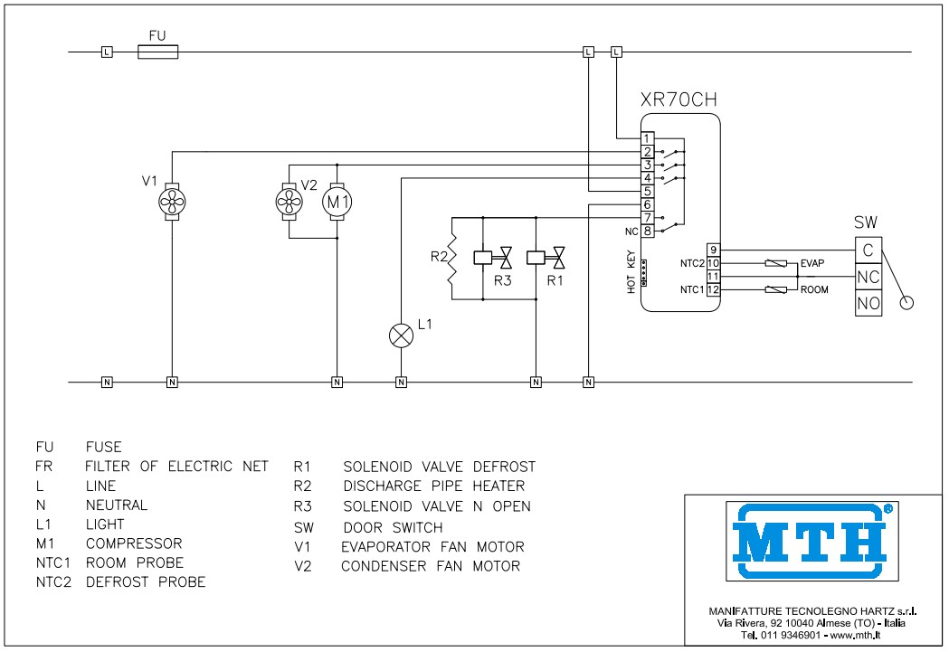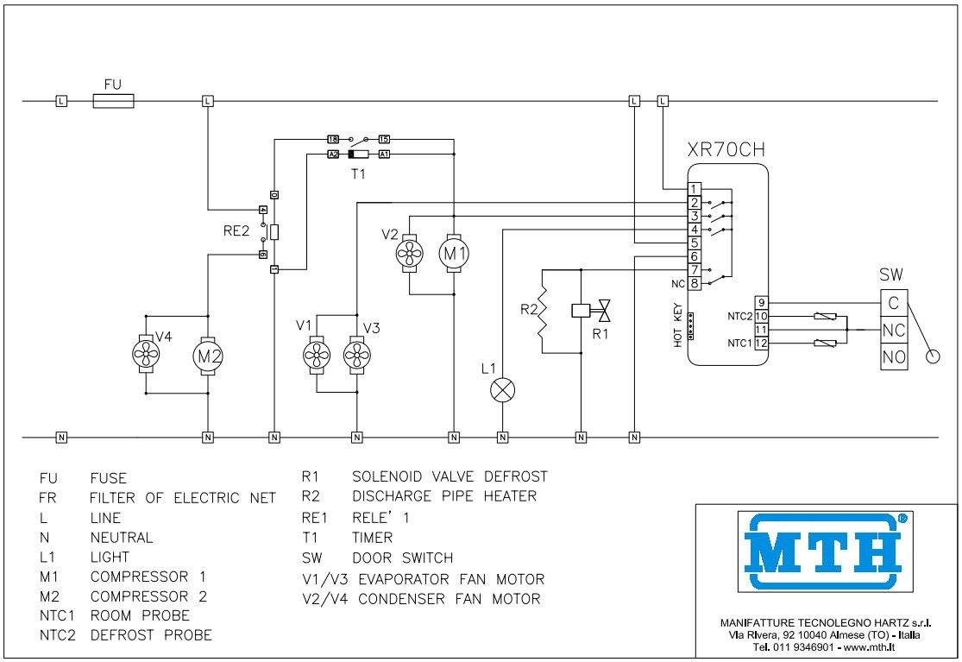

Fig. AN4

-

Schema elettrico 1913EL01

-

Wiring diagram 1913EL01

Fig. AN5

-

Schema elettrico 1913EL02

-

Wiring diagram 1913EL02

|  |  |  |  |
| --- | --- | --- | --- |
| **LEGENDA - KEY LEGEND** | | | |
| **FU** | **FUSIBILE**  **FUSE** | **NTC2** | **SONDA SBRINAMENTO**  **DEFROST PROBE** |
| **FR** | **FILTRO RETE ELETTRICA**  **ELECTRIC NET FILTER** | **T** | **TIMER**  **TIMER** |
| **RE** | **RELÉ**  **RELAY** | **R1** | **VALVOLA SOLENOIDE SBRINAMENTO**  **SOLENOID DEFROST VALVE** |
| **L** | **LINEA**  **LINE** | **R2** | **RESISTENZA SCARICO CONDENSA**  **DISCHARGE PIPE HEATER** |
| **N** | **NEUTRO**  **NEUTRAL** | **SW** | **INTERRUTTORE PORTA**  **DOOR SWITCH** |
| **L1** | **LUCE**  **LIGHT** | **V1/V3** | **MOTORI VENTOLE EVAPORATORE**  **EVAPORATOR FAN MOTOR** |
| **M1,M2** | **COMPRESSORI**  **COMPRESSORS** | **V2/V4** | **MOTORI VENTOLE CONDENSATORE**  **CONDENSER FAN MOTOR** |
| **NTC1** | **SONDA TEMPERATURA CELLA**  **ROOM TEMPERATURE PROBE** |  |  |

#### NOTE

………………………………………………………………………………….

…………………………………………………………………………………. ………………………………………………………………………………….

…………………………………………………………………………………. ………………………………………………………………………………….

………………………………………………………………………………….

………………………………………………………………………………….

…………………………………………………………………………………. …………………………………………………………………………………. ………………………………………………………………………………….

………………………………………………………………………………….

………………………………………………………………………………….

………………………………………………………………………………….

………………………………………………………………………………….

………………………………………………………………………………….

………………………………………………………………………………….

………………………………………………………………………………….

………………………………………………………………………………….

………………………………………………………………………………….

………………………………………………………………………………….

………………………………………………………………………………….

………………………………………………………………………………….

………………………………………………………………………………….

………………………………………………………………………………….

………………………………………………………………………………….

………………………………………………………………………………….

………………………………………………………………………………….

………………………………………………………………………………….

…………………………………………………………………………………. …………………………………………………………………………………. ………………………………………………………………………………….

………………………………………………………………………………….

………………………………………………………………………………….

………………………………………………………………………………….

………………………………………………………………………………….

#### NOTE

………………………………………………………………………………….

…………………………………………………………………………………. ………………………………………………………………………………….

…………………………………………………………………………………. ………………………………………………………………………………….

………………………………………………………………………………….

………………………………………………………………………………….

…………………………………………………………………………………. …………………………………………………………………………………. ………………………………………………………………………………….

………………………………………………………………………………….

………………………………………………………………………………….

………………………………………………………………………………….

………………………………………………………………………………….

………………………………………………………………………………….

………………………………………………………………………………….

………………………………………………………………………………….

………………………………………………………………………………….

………………………………………………………………………………….

………………………………………………………………………………….

………………………………………………………………………………….

………………………………………………………………………………….

………………………………………………………………………………….

………………………………………………………………………………….

………………………………………………………………………………….

………………………………………………………………………………….

………………………………………………………………………………….

………………………………………………………………………………….

…………………………………………………………………………………. …………………………………………………………………………………. ………………………………………………………………………………….

………………………………………………………………………………….

………………………………………………………………………………….

………………………………………………………………………………….

………………………………………………………………………………….





MTH srl | Via Rivera, 92 | 10040 Almese (TO) | Italy

Tel +39.011.9351580 | mthsrl@mth.it | **mth.it**