|  |  |  |  |
| --- | --- | --- | --- |
|  |  | Site Address: |  |
|  |  |  |  |
| Date: |  |  |  |
| Site Name: |  |  |  |
| Cabinet ID: |  | Remis Job No: |  |

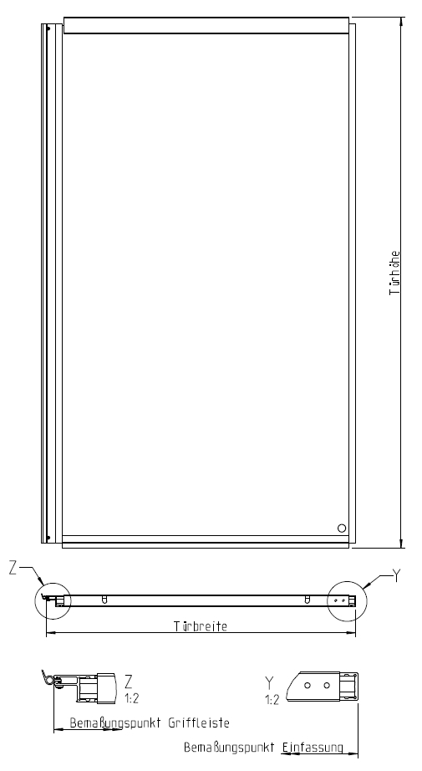

Height dimension A: mm

Width dimension B: mm

Sliding door: mm

R/H opening **(Rear)**

L/H opening **(Front)**

Additional Requirements

1. Photos showing dimensions (Height and Width) and type of door (Hinged or Sliding).
2. Photos showing Serial Plate of Cabinet
3. RAL Colour of Door

Works required please state below – please send supporting pictures:

|  |
| --- |
|  |
|  |
|  |
|  |
|  |